Mathematics for Game Developers

# Mathematics for Game Developers

### Downey Unified School District

### Publisher



Creative Commons International

CCBY 4.0 license

Mathematics for Game Developers fully meets accessibility standards.

https://OER4CTE.ORG

# Mathematics for Game Developers

### Downey Unified School District, Publisher



### Downey Unified School District (DUSD) Team

**DUSD Vision**

All students graduate with a 21st Century education that ensures they are college and career ready, globally competitive and citizens of strong character.

**DUSD Mission**

Downey Unified School District is committed to developing all students to be self-motivated learners and productive, responsible, and compassionate members of an ever-changing global society. Our highly qualified staff foster meaningful relationships with students, parents, and the community while providing a relevant and rigorous curriculum in facilities that advance teaching and learning.

**DUSD Administration**

Superintendent John A. Garcia, Jr., Ph.D.

Assistant Superintendent Roger Brossmer, Ed.D.

Director, College and Career Readiness John M. Harris

**DUSD Board of Education**

D. Mark Morris, President and Trustee Area 6

Barbara R. Samperi, Vice President and Trustee Area 7

Martha E. Sodetani, Clerk and Trustee Area 1

Giovanna Perez-Saab, Trustee Area 3

Jose J. Rodriguez, Trustee Area 2

Linda Salomon Saldaña, Trustee Area 4

Nancy A. Swenson, Trustee Area 5

**Additional Support**

California Community College K12 Srong Workforce Program Round 3 award: Open-Source Downey taps into DUSD’s existing ecosystem and builds a culture of open education resources (OER) and industry collaborative work-based learning to be shared with high schools across the state.

### Open Education Resources (OER) Team

Denny Burzynski, Author

Kelly Cooper, Project Manager

Veronika Focht, Book Designer, Technical Editor

June Bayha, Thought Partner

Muhammad Awais, Technical Reviewer

### About the Author

Denny Burzynski has a Master’s Degree in Mathematics from the California State University, Long Beach, and has taught mathematics at California and Nevada community colleges for 45 years. His programming experience started when Fortran IV was popular and used line numbers and punch cards. With some of his friends, Denny authored six college mathematics textbooks from basic arithmetic, elementary and intermediate algebra, college algebra, to applied calculus. Denny presented at many mathematics conferences all over the country, spent a semester interning as a program director at the National Science Foundation in Washington, D.C., and served as president of both the California Mathematics Council Community Colleges and the Nevada Mathematical Association of Community Colleges.

### Introduction

Are you reading this note because you want to develop computer games or write computer programs that perform particular tasks or create whimsical illusions? How is your background in mathematics? Good? Okay? Not sure? To design and program fun and adventurous games, you may not need deep knowledge of mathematics to understand what programming commands do and how to use them to your advantage. In this book, we focus on a few of the mathematical instruments used in programming languages such as C# and C++. Programming languages have libraries of commands that you can use to write programs, and their commands come from mathematical instruments. In Mathematics for Game Developers, we explore the basic ideas of how mathematical instruments control action and motion in the games you develop. And, we introduce technology that performs all the mathematical calculations you might need. How awesome is that!

We clearly define four mathematical instruments: vectors, matrices, and the sine and cosine functions and describe what they do. We intend to add practical insight to your programming experience. Programmers use commands to direct computers to perform specific tasks. Commands commonly used in C# and C++ include mathematical instruments such as the Quaternion, the Euler angle, and the rotation matrix that have been around a long time. Quaternions were developed in 1843 by the Irish Mathematician William Rowan Hamilton and matrices in 1850 by the English mathematician James Sylvester. Hipparchus of Nicea (ancient Greece), who lived from 180-125 BCE, likely compiled the first trigonometric table.

Directing your computer to rotate an object or move it vertically or horizontally uses a command born from one or more of these instruments. Can you imagine what Hamilton, Euler, and Hipparchus would think if they knew what you are planning to do with their mathematics!

## Table of Contents

UNIT 1 SOME BASIC ALGEBRA 4

1.1 Constants, Variables, and Expressions 4

A BIT MORE DETAIL 5

MATHEMATICAL EXPRESSIONS 6

USING TECHNOLOGY 7

1.1 TRY THESE 8

UNIT 2 VECTORS IN TWO DIMENSIONS 9

2.1 Vectors 9

VECTORS IN STANDARD POSITION 10

COMPONENTS OF A VECTOR 10

ROW AND COLUMN FORMS OF A VECTOR 11

EQUAL VECTORS 11

2.1 TRY THESE 12

2.2 Addition, Subtraction, and Scalar Multiplication of Vectors 13

ADDITION & SUBTRACTION OF VECTORS 13

SCALARS 15

USING TECHNOLOGY 16

2.2 TRY THESE 16

2.3 Magnitude, Direction, and Components of a Vector 17

THE MAGNITUDE OF A VECTOR 17

THE DIRECTION OF A VECTOR 17

THE COMPONENTS OF A VECTOR 19

USING TECHNOLOGY 20

2.3 TRY THESE 21

2.4 The Dot Product of Two Vectors, the Length of a Vector, and the Angle Between Two Vectors 22

THE DOT PRODUCT OF TWO VECTORS 22

THE LENGTH OF A VECTOR 23

THE ANGLE BETWEEN TWO VECTORS 24

USING TECHNOLOGY 25

2.4 TRY THESE 26

2.5 Parallel and Perpendicular Vectors, The Unit Vector 27

PARALLEL AND ORTHOGONAL VECTORS 27

THE UNIT VECTOR 28

USING TECHNOLOGY 29

2.5 TRY THESE 30

2.6 The Vector Projection of One Vector onto Another 31

PROJECTION 31

USING TECHNOLOGY 32

2.6 TRY THESE 35

UNIT 3 VECTORS IN THREE DIMENSIONS 36

3.1 Three Dimensional Vectors 36

3-DIMENSIONAL SPACE 36

THE DISTANCE BETWEEN TWO POINTS IN 2 & 3-DIMENSIONAL SPACE 36

USING TECHNOLOGY 37

THE EQUATION OF A CIRCLE AND A SPHERE 38

3.1 TRY THESE 39

3.2 Magnitude and Direction Cosines of a Vector 40

THE MAGNITUDE OF A VECTOR 40

THE DIRECTION COSINES OF VECTORS IN 2- AND 3-DIMENSIONS 41

USING TECHNOLOGY 43

3.2 TRY THESE 44

3.3 Arithmetic on Vectors in 3-Dimensional Space 45

ADDITION & SUBTRACTION OF VECTORS 45

SCALAR MULTIPLICATION 46

USING TECHNOLOGY 47

3.3 TRY THESE 48

3.4 The Unit Vector in 3-Dimensions and Vectors in Standard Position 49

THE UNIT VECTOR IN 3-DIMENSIONS 49

VECTORS IN STANDARD POSITION 50

NORMALIZING A VECTOR 52

3.4 TRY THESE 52

USING TECHNOLOGY 52

3.5 The Dot Product, Length of a Vector, and the Angle between Two Vectors in Three Dimensions 53

THE DOT PRODUCT OF TWO VECTORS 53

THE LENGTH OF A VECTOR IN THREE DIMENSIONS 54

THE ANGLE BETWEEN TWO VECTORS 55

USING TECHNOLOGY 56

3.5 TRY THESE 57

3.6 The Cross Product: Algebra 58

THE CROSS PRODUCT OF TWO VECTORS 58

USING TECHNOLOGY 60

THE RIGHT-HAND RULE 61

USING TECHNOLOGY 62

3.6 TRY THESE 62

3.7 The Cross Product: Geometry 63

THE CROSS PRODUCT OF TWO VECTORS AND THE RIGHT-HAND RULE 63

THE GEOMETRY OF THE CROSS PRODUCT 63

USING TECHNOLOGY 65

AREA OF A PARALLELOGRAM 65

THE CROSS PRODUCT OF PERPENDICULAR AND PARALLEL VECTORS 66

3.7 TRY THESE 68

UNIT 4 MATRICES 69

4.1 Matrices 69

MATRIX 69

DIMENSION OF A MATRIX 69

ELEMENTS OF A MATRIX 69

EQUAL MATRICES 70

SQUARE MATRICES 70

MAIN DIAGONAL OF A SQUARE MATRIX 72

THE IDENTITY MATRIX 72

THE ZERO MATRIX 72

THE TRANSPOSE OF A MATRIX 73

ROW MATRICES AND COLUMN MATRICES 73

VECTORS AS MATRICES 73

4.1 TRY THESE 74

4.2 Addition, Subtraction, Scalar Multiplication, and Products of Row and Column Matrices 75

Addition and Subtraction of Matrices 75

TRY THIS: 75

Scalar Multiplication 75

Multiplication with Row and Column Matrices 76

Motivation for the Process of Multiplication with Row and Column Matrices 77

Important Observation – See this 78

Dimension Matters 78

4.2 Try these 79

4.3 Matrix Multiplication 80

Compatible Matrices 80

Matrices as Collections of Row and Column Matrices 80

Multiplication of Two Matrices 81

Using Technology 82

4.3 Try these 83

4.4 Rotation Matrices in 2-Dimensions 84

The Rotation Matrix 84

The Rotation Process 84

Using Technology 86

4.4 Try these 87

4.5 Finding the Angle of Rotation Between Two Rotated Vectors in 2-Dimensions 88

Given the Rotated Vector, Find the Angle of Rotation 88

Using Technology 89

4.5 Try these 91

4.6 Rotation Matrices in 3-Dimensions 92

The Three Basic Rotations 92

The Rotation Matrices 92

The Rotation Process 93

The –axis 93

The –axis 93

The –axis 93

Using Technology 95

4.6 Try these 97

UNIT 5 SOME BASIC TRIGONOMETRY 98

5.1 The Basic Trigonometric Functions 98

Right Triangle Trigonometry 98

The Sine of an Angle 99

The Cosine of an Angle 99

The tangent of an Angle 99

Using Technology 100

5.1 Try these 102

5.2 Circular Trigonometry 103

The Sine Function on the Unit Circle 103

The Cosine Function on the Unit Circle 104

The Sine and Cosine Functions on any Circle 104

5.2 Try these 107

5.3 Graphs of the Sine Function 108

Discrete Graph of the Sine Function from 0° to 90° 108

Graphs of the Heights 109

The Continuous Sine Curve from 0° to 90° 110

The Continuous Sine Curve from 0° to 180° 110

The Continuous Sine Curve from 0° to 360° 110

The Extended Sine Curve 111

5.3 Try these 112

5.4 Graphs of the Cosine Function 113

Discrete Graph of the Cosine Function from 0° to 360° 113

The Extended Cosine Curve 114

5.4 Try these 115

5.5 Amplitude and Period of the Sine and Cosine Functions 116

Amplitude 116

THE AMPLITUDE OF AND 117

Period 117

THE PERIOD OF AND 117

Using Technology 118

5.5 Try these 120

ANSWERS TO TRY THESE 122

1.1 Constants, Variables, and Expressions 122

2.1 Vectors 122

2.2 Addition, Subtraction, and Scalar Multiplication of Vectors 122

2.3 Magnitude, Direction, and Components of a Vector 122

2.4 The Dot Product of Two Vectors, the Length of a Vector, and the Angle Between Two Vectors 123

2.5 Parallel and Perpendicular Vectors, The Unit Vector 123

2.6 The Vector Projection of One Vector onto Another 123

3.1 Three Dimensional Vectors 123

3.2 Magnitude and Direction Cosines of a Vector 123

3.3 Arithmetic on Vectors in 3-Dimensional Space 123

3.4 The Unit Vector in 3-Dimensions and Vectors in Standard Position 124

3.5 The Dot Product, Length of a Vector, and the Angle between Two Vectors in Three Dimensions 124

3.6 The Cross Product: Algebra 124

3.7 The Cross Product: Geometry 124

4.1 Matrices 125

4.2 Addition, Subtraction, Scalar Multiplication, and Products of Row and Column Matrices 125

4.3 Matrix Multiplication 126

4.4 Rotation Matrices in 2-Dimensions 126

4.5 Finding the Angle of Rotation Between Two Rotated Vectors in 2-Dimensions 127

4.6 Rotation Matrices in 3-Dimensions 127

5.1 The Basic Trigonometric Functions 127

5.2 Circular Trigonometry 127

5.3 Graphs of the Sine Function 128

5.4 Graphs of the Cosine Function 128

5.5 Amplitude and Period of the Sine and Cosine Functions 129

Teacher Notes 130

1.1 Constants, Variables, and Expressions 130

2.1 Vectors 131

2.2 Addition, Subtraction, and Scalar Multiplication of Vectors 132

2.3 Magnitude, Direction, and Components of a Vector 135

2.4 The Dot Product of Two Vectors, the Length of a Vector, and the Angle Between Two Vectors 137

2.5 Parallel and Perpendicular Vectors, The Unit Vector 139

2.6 The Vector Projection of One Vector onto Another 141

3.1 Three Dimensional Vectors 142

3.2 Magnitude and Direction Cosines of a Vector 143

3.3 Arithmetic on Vectors in 3-Dimensional Space 144

3.4 The Unit Vector in 3-Dimensions and Vectors in Standard Position 145

3.5 The Dot Product, Length of a Vector, and the Angle between Two Vectors in Three Dimensions 146

3.6 The Cross Product: Algebra 148

3.7 The Cross Product: Geometry 149

4.2 Addition, Subtraction, Scalar Multiplication, and Products of Row and Column Matrices 150

4.3 Matrix Multiplication 151

4.4 Rotation Matrices in 2-Dimensions 152

4.5 Finding the Angle of Rotation Between Two Rotated Vectors in 2-Dimensions 156

4.6 Rotation Matrices in 3-Dimensions 158

5.1 The Basic Trigonometric Functions 160

5.2 Circular Trigonometry 162

5.3 Graphs of the Sine Function 163

5.4 Graphs of the Cosine Function 163

5.5 Amplitude and Period of the Sine and Cosine Functions 164

# UNIT 1 SOME BASIC ALGEBRA

## 1.1 Constants, Variables, and Expressions

Constants and variables, at least one of these objects appear in every mathematical expression one can imagine. Let’s get a sense of just what they are.

A **VARIABLE** is a quantity that has a capacity for change in a particular context.

A **CONSTANT** is a quantity that has no capacity for change in a particular context.

Let’s put both in the context of hiring a programmer to write a program that performs some particular task. Suppose there are three programmers, *A*, *B*, and *C*, we are considering.

**Programmer A charges a flat fee of $25,000 for writing the program.**

Programmer *A*’s fee is constant. In this context, the fee has no capacity for change. The fee is $25,000, no more, no less. Outside this context, maybe writing a less complicated program, the flat fee may be less than $25,000.

**Programmer B charges $100/hour for writing the program.**

Programmer *B‘s* fee is variable. In this context, the fee has the capacity for change. The total fee varies with the amount of time taken to write the program.

**Programmer C charges a flat fee of $15,000 and $100/whole hour (1, 2, 3, …, 50) for writing the program.**

Programmer *C*’s fee is variable since the total fee varies since it has the capacity for change. The fee varies with the amount of time taken to write the program. Programmer *C*'s fee structure comprises both a constant, the flat fee of $15,000, and a variable, the $100/ whole hour. But because it contains a variable, the entire quantity is variable.

### A BIT MORE DETAIL

**CONSTANTS** are represented with numerals (1, 2, 3, …) and, in special cases, letters or symbols. The constant pi is represented with the Greek letter , where is the non-repeating and non-terminating decimal number 3.14159….

**VARIABLES** are typically represented with symbols or a group of symbols. You’ve seen these. In fact, you usually see a variable represented with the letter . Why , you ask?

Check out this short TED talk to hear as good a theory as I have ever heard. It is worth your time. <https://tinyurl.com/thevariablex>

It is convenient to think of a variable as a container that can hold different objects at different times. In the programmer example, we might let the letter represent the number of hours Programmer *C* takes to write the program. The number of hours can vary from, say, 1 to 50. Think of as a container into which could be placed the numbers 1, 2, 3, and so on up to and including 50.

1. If *C* takes only 1 hour to write the program, think of the number 1 being placed into the container named letter . Then *C*’s total fee would be

$15,000 + 1×$100 = $15,100

1. If *C* takes 2 hours to write the program, think of the number 2 being placed into the container named letter . Then *C*’s total fee would be

$15,000 + 2×$100 = $15,200

1. If *C* takes 50 hours to write the program, think of the number 50 being placed into the container named letter . Then *C*’s total fee would be

$15,000 + 50×$100 = $20,000

### MATHEMATICAL EXPRESSIONS

A MATHEMATICAL EXPRESSION is a constant, a variable, or a finite combination of constants and variables constructed together with mathematical operations (like +, –, x ÷).

Think of a mathematical expression (or just expression) as a set of computing instructions that converts an INPUT value to an OUTPUT value.

For example, using the letter to represent the number of hours *C* takes to write the program, we could express Programmer *C*'s total fee with the expression

15,000 + 100

The variable (the container named ) can hold, one at a time, any of the fifty numbers 1, 2, 3, …50. See this expression as a set of computing instructions that take an input value, one of the numbers 1, 2, 3, …50, and converts it to a single output value.

**Try to read the instructions in English:**

15,000 + 100🡪 to get Programmer *C*’s total fee, multiply the number of hours taken to write the program by 100, then add 15,000. Or, maybe better, Programmer *C*'s total fee is $15,000 more than $100 times the number of hours worked.

### USING TECHNOLOGY

We can use technology to evaluate expressions.

Go to www.wolframalpha.com.

To evaluate 15,000+100𝑥 at x = 14, use the “evaluate” command. Enter evaluate 15000 + 100x, x = 14 in the entry field. Wolframalpha tells you what it thinks you entered, then tells you its answer. In this case, .

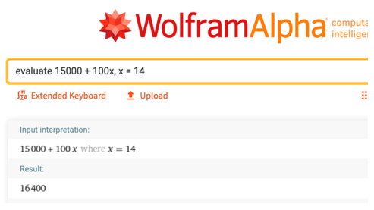

To evaluate at x = 14 through 18, use the “table” command. Enter table 15000 + 100x, x = 14.. 18 in the entry field. Wolframalpha tells you what it thinks you entered, then tells you its answer. In this case it shows you a table with answers for .

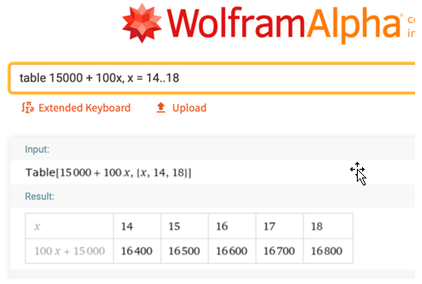­­

### 1.1 TRY THESE

1. Suppose a subscription to a photograph service costs $50/year and that each downloaded photograph costs $2.
   1. Which of the two quantities is the variable quantity?
   2. Which of the two quantities is the constant?
   3. Write the expression that produces the annual cost of subscribing and downloading number of photographs.
   4. What is the annual cost of subscribing and downloading 20 photographs?

1. What is the minimum number of cookies a person must eat to be happy? What is the minimum number of cookies beyond that number must eat to feel sick? These numbers are likely different for all of us. Let the variable represent the minimum number of cookies someone must eat to be happy, and the variable be the minimum number that makes that person sick.
   1. How many variable quantities are in this problem?
   2. Are there any constants in this problem?

# UNIT 2 VECTORS IN TWO DIMENSIONS

## 2.1 Vectors

Vectors are fundamental objects in applied mathematics; they efficiently convey information about a mathematical or physical object. Let's get a sense of what they are.

A **VECTOR** is a representation of an object that has both direction and magnitude. By direction, we mean the place toward which something faces, and by magnitude, we mean the size of something.

A vector can be depicted visually by an arrow, with an initial point called the tail and a terminal point called the head. The length of the arrow represents the vector's magnitude.

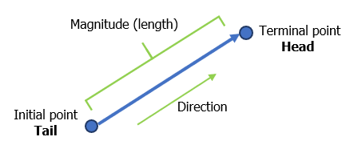

Vectors are often named using a bold-typed letter with an arrow on top of it. For example, the vector in the picture could be named or .

An example of a vector is a car’s velocity. Velocity is a vector since it has both magnitude (speed) and direction. A car might be moving west at 60 mph. Other examples of vectors are displacement, acceleration, and force.

The temperature of some medium is not a vector since it has only magnitude. But if the medium is being heated, its temperature is increasing and has a direction; it is going upward. The increase or decrease in temperature is a vector.

### VECTORS IN STANDARD POSITION

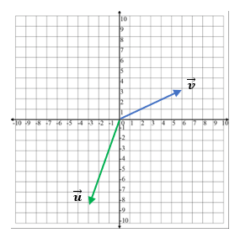

A vector with its initial point at the origin in a Cartesian coordinate system is said to be in STANDARD POSITION. The vector in the diagram has its initial point at the origin, and its terminal point at.

### COMPONENTS OF A VECTOR

Vectors in the -plane can be broken into their **horizontal** and **vertical** components.

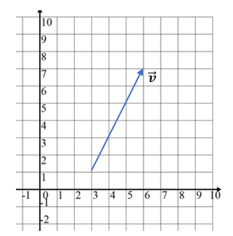

For example, the vector in the diagram  
can be broken into two components,

1. its horizontal, or -component, and
2. its vertical, or -component.

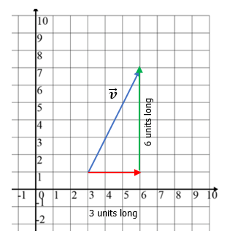

The vector in component form is expressed using angle brackets as , where

1. the first component, 3 is the length and direction of its

-component, and

1. the second component, 6 is the length and direction of its -component.

The vector in the picture below has

**FIRST COMPONENT = (terminal -value) – (initial -value)** = , and

**SECOND COMPONENT = (terminal -value) – (initial -value)** = ,

so that .

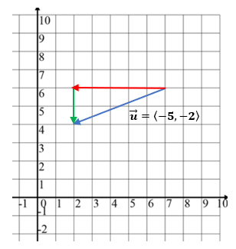

### ROW AND COLUMN FORMS OF A VECTOR

Vectors are represented by a single column matrix or a single row matrix. The vectors , and above, can be represented by the 2x1 row matrix and the 1x2 column matrix, respectively as

and

### EQUAL VECTORS

Two vectors are EQUAL if they have the same direction and magnitude. They may start and end at different positions, but their representing arrows will be parallel.

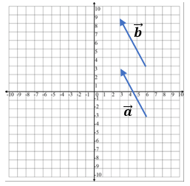

In the diagram vectors and are equal but appear in different locations in the -plane.

### 2.1 TRY THESE

1. Express the vectors and in component form.

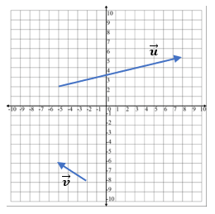

1. Explain why the two vectors are equal.

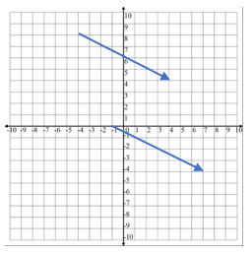

## 2.2 Addition, Subtraction, and Scalar Multiplication of Vectors

### ADDITION & SUBTRACTION OF VECTORS

To add or subtract two vectors, add, or subtract their corresponding components.

To **ADD** the vectors and , begin by writing each in component form.

Example (1)

|  |  |
| --- | --- |
| Image of two vectors in a 2-dimensional coordinate system. | and  ADD their corresponding components.  So, |

|  |  |
| --- | --- |
| Now, graph this sum.   * Start at the origin. * Since the horizontal component is 3, move 3 units to the *right*. * Since the vertical component is , move 5 units *downward*. | Image of two vectors in a 2-dimensional coordinate system and a demonstration of graphing their sum. |

The addition of two vectors and can be demonstrated by placing the tail of one vector at the head of the other. Then connect the tail of to the head of .

Example (2)

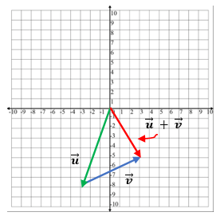

To **SUBTRACT** the vector from the vector , begin by writing each in component  
 form.

Example (3)

|  |  |
| --- | --- |
| Image of two vectors in a 2-dimensional coordinate system. | and  SUBTRACT the components of from the corresponding components of .  So, |

|  |  |
| --- | --- |
| Now, graph this sum.   * Start at the origin. * Since the horizontal component is 9, move 9 units to the *right*. * Since the vertical component is 11, move 11 units *upward*. | Image of two vectors in a 2-dimensional coordinate system and an example of graphing their subtraction. |

### SCALARS

In contrast to a vector, and having both direction and magnitude, a SCALAR is a physical quantity defined by only its magnitude.

Examples are speed, time, distance, density, and temperature. They are represented by real numbers (both positive and negative), and they can be operated on using the regular laws of algebra.

The term *scalar* derives from this usage: *a scalar is that which scales, resizes a vector*.

Scalar multiplication is the multiplication of a vector by a real number (a scalar).

Suppose we let the letter represent a real number and be the vector Then, the scalar multiple of the vector is

To multiply a vector by a scalar (a constant), multiply each of its components by the constant.

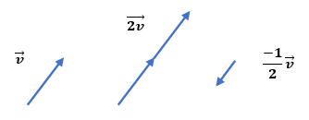

1. Suppose and .

Then 3

1. Suppose and and .

Then

1. Suppose and and .

Then

### USING TECHNOLOGY

We can use technology to add and subtract vectors and to multiply a vector by a scalar.

Go to www.wolframalpha.com.

For the vectors and , use WolframAlpha to find . Enter evaluate 3<-2, 6> + 4<5, 3> in the entry field. Wolframalpha tells you what it thinks you entered, then tells you its answer. In this case, .

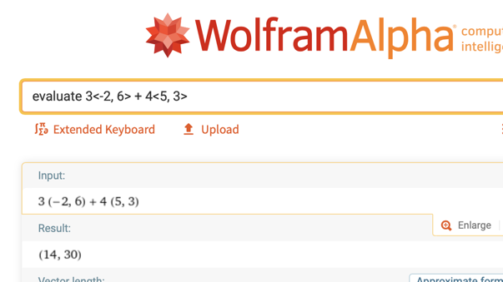

### 2.2 TRY THESE

1. Find the sum of the two vectors and .
2. Subtract the vector from the vector .
3. Perform the operation .

## 2.3 Magnitude, Direction, and Components of a Vector

### THE MAGNITUDE OF A VECTOR

It is productive to represent the horizontal and vertical components of a vector as and , respectively.

|  |  |
| --- | --- |
| The magnitude (the length) of a vector is | A diagram showing the magnitude of a vector and its horizontal and vertical components. |

|  |  |
| --- | --- |
| The vector has magnitude:    = =  Interpret this as the length of the vector is units. | An example of a vector magnitude in a 2-dimension coordinate system. |

### THE DIRECTION OF A VECTOR

The direction of a vector is the angle the vector makes with the positive -axis.

It is typically represented with the uppercase Greek letter theta . We use some trigonometry to determine the angle .

|  |  |
| --- | --- |
| or  The angle is always between 0° and 360°. | Image illustrating a direction of a vector and the angle it makes with the positive x-axis. |

To approximate the direction of the vector , use with and

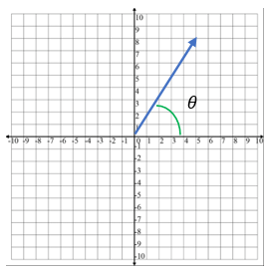

Using a calculator, we get

To approximate the direction of the vector , use with and

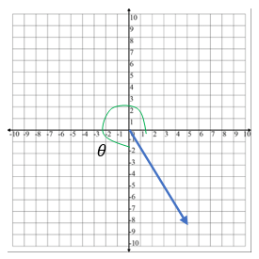

Using a calculator, we get

Vertical component is in Quadrant IV and must be in the interval , therefore we calculate by

### THE COMPONENTS OF A VECTOR

The lengths of the - and - components of a vector

in two dimensions can be found using trigonometric ratios.

and

is the horizontal component of and is the vertical component.

The angle is always between 0° and 360°.

Suppose the magnitude of a vector is 20 units, and that makes a 60° angle with the horizontal. Then, the components of are

and

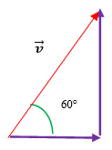

So, we could write as

### USING TECHNOLOGY

We can use technology to determine the magnitude of a vector.

Go to www.wolframalpha.com.

To find the magnitude of the vector enter magnitude of <2,4> in the entry field. Wolframalpha tells you what it thinks you entered, then tells you its answer. In this case, .

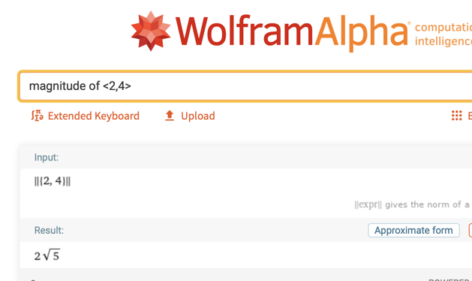

To find the direction of the vector enter direction of the vector <5,8>in the entry field. Wolframalpha answers .

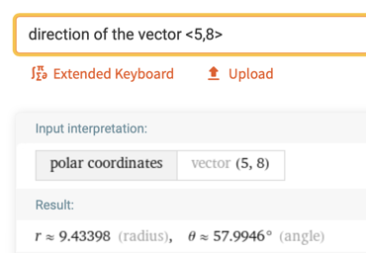

### 2.3 TRY THESE

1. Find the magnitude of the vector
2. Find the magnitude of the vector
3. Find the components of the vector if the magnitude of is 6 and it makes a 30° angle with the horizontal.
4. Approximate the direction of the vector .

## 2.4 The Dot Product of Two Vectors, the Length of a Vector, and the Angle Between Two Vectors

### THE DOT PRODUCT OF TWO VECTORS

The length of a vector or the angle between two vectors and can be found using the dot product.

The dot product of vectors and

is a scalar (real number) and is defined to be

Since and are real numbers, you can see that the dot product is itself a real number and not a vector.

To compute the dot product of the vectors and , we compute

Example (1)

Since the dot product is a scalar, it follows the properties of real numbers.

**PROPERTIES OF THE DOT PRODUCT**

1. , the dot product is commutative
2. , the dot product distributes over vector addition
3. , the dot product with the zero vector, is the scalar 0.

Compute the dot product ,

Example (2)

where , , and .

### THE LENGTH OF A VECTOR

The length (magnitude) of a vector you know is given by . The length can also be found using the dot product. If we dot a vector with itself, we get

By Vector Property 4, . This gives .

Taking the square root of each side produces

Which is the length of the vector .

The dot product of a vector with itself gives the length of the vector.

Use the dot product to find the length of the vector .

Example (3)

In this case, and

Using , we get

The length of the vector is units.

### THE ANGLE BETWEEN TWO VECTORS

The dot product and elementary trigonometry can be used to find the angle between two vectors.

If is the smallest nonnegative angle between two non-zero vectors and , then

cos or

where and and

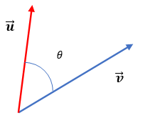

Find the angle between the vectors and .

Example (4)

Using , we get

We conclude that the angle between these two vectors is close to 94.4°.

### USING TECHNOLOGY

We can use technology to find the angle between two vectors.

Go to www.wolframalpha.com.

To find the angle between the vectors and , enter angle between the vectors <5, -3> and <2, 4> in the entry field. Wolframalpha tells you what it thinks you entered, then tells you its answer. In this case, , rounded to one decimal place.

**Image of a calculation result of an angle between two vectors using WolframAlpha.**

### 2.4 TRY THESE

1. Find the dot product of the vectors and .
2. Find the dot product of the vectors and .
3. Find the length of the vector .

4.Find the length of the vector .

5.Find the angle between the vectors and .

6.Find angle between the vectors and .

## 2.5 Parallel and Perpendicular Vectors, The Unit Vector

### PARALLEL AND ORTHOGONAL VECTORS

Two vectors and are **parallel** if the angle between them is 0° or 180°.

Also, two vectors and are parallel to each other if the vector is some multiple of the vector .That is, they will be parallel if the vector , for some real number . That is, is some multiple of .

Two vectors and are **orthogonal** (perpendicular to each other) if the angle between them is 90° or 180°.

Use this shortcut: Two vectors are perpendicular to each other if their dot product is 0.

The two vectors and are parallel to each other since the angle between them is .

Example (1)

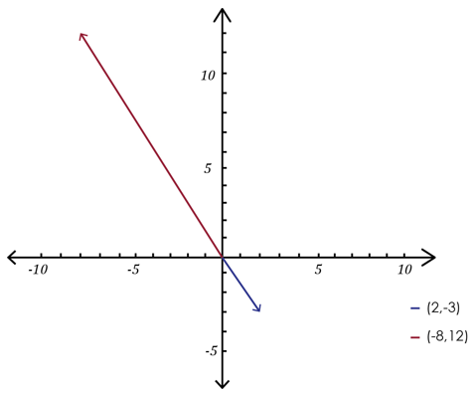

To show that the two vectors and are orthogonal (perpendicular to each other), we just need to show that their dot product is 0.

Example (2)

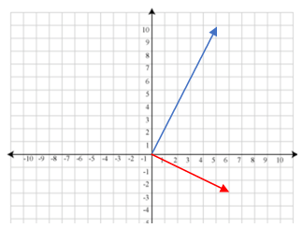

### THE UNIT VECTOR

A unit vector is a vector of length 1.

A unit vector is a vector of length 1. A unit vector in the same direction as the vector is often denoted with a “hat” on it as in . We call this vector “v hat.”

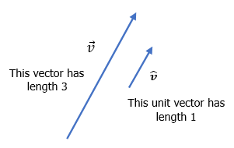

The unit vector corresponding to the vector is defined to be

The unit vector corresponding to the vector is

Example (3)

### USING TECHNOLOGY

We can use technology to find the angle between two vectors.

Go to www.wolframalpha.com.

To show that the vectors and are parallel**,** enter angle between the vectors <5, -3> and <2, 4> in the entry field. Wolframalpha tells you what it thinks you entered, then tells you its answer. In this case, , indicating the two vectors are parallel.

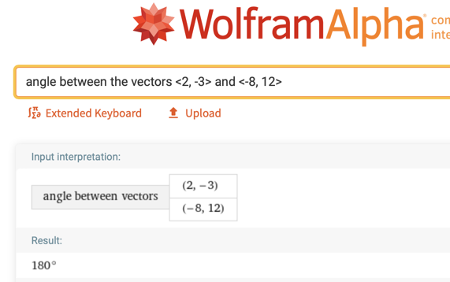

### 2.5 TRY THESE

1. Determine if the vectors and are parallel to each other, perpendicular to each other, or neither parallel nor perpendicular to each other.
2. Determine if the vectors and are parallel to each other, perpendicular to each other, or neither parallel nor perpendicular to each other.
3. Determine if the vectors and are parallel to each other, perpendicular to each other, or neither parallel nor perpendicular to each other.

4.Find the unit vector corresponding to the vector .

## 2.6 The Vector Projection of One Vector onto Another

### PROJECTION

Let’s project vector onto the vector .

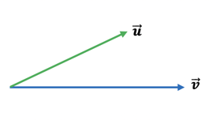

To do so, imagine a light bulb above shining perpendicular onto .

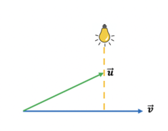

The light from the bulb will cast a shadow of onto ,and it is this shadow that we are looking for. The shadow is the projection of onto .

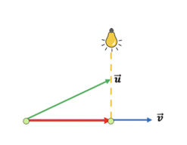

The red vector is the projection of onto . The notation commonly used to represent the projection of onto is .

Vector parallel to with magnitude in the direction of is called projection of onto .

The formula for is

To find the projection of ⟨4, onto ⟨2, , we need to compute both the dot product of and , and the magnitude of , then apply the formula.

Example (1)

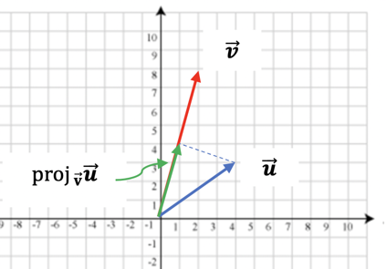

### USING TECHNOLOGY

We can use technology to determine the projection of one vector onto another.

Go to www.wolframalpha.com.

To find the projection of onto ⟨2, , use the “projection” command. In the entry field enter projection of <4, 3> onto <2, 8>.

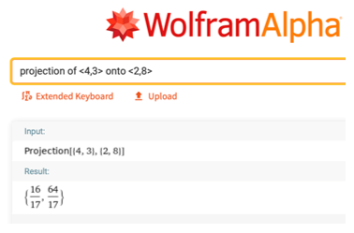

Wolframalpha tells you what it thinks you entered, then tells you its answer. In this case, .

As an applied example, suppose a video game has a ball moving near a wall.

Example (2)

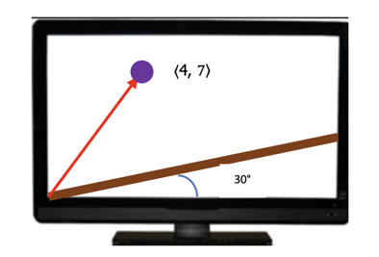

We take the origin at the bottom-left-most corner of the screen. The wall is at a 30° angle to the horizontal, and at a point in time, the ball is at position ⟨4,. To find the perpendicular distance from the ball to the wall, we use the projection formula to project the vector ⟨4, onto the wall.

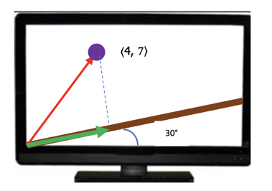

We begin by decomposing into two vectors and so that and lies along the wall**.**

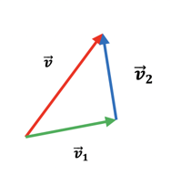

The length (magnitude) of the vector is then the distance from the ball to the wall.

The vector is the projection of onto the wall. We can get by scaling (multiplying) a unit vector that lies along the wall and, thus, along with .

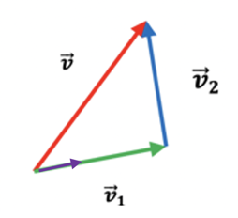

Since lies at a 30° angle to the horizontal, , using the projection formula, we get the projection of that lies along the wall.

|  |  |
| --- | --- |
|  | An illustration showing vector decompose into two vectors creating a triangle. |

|  |  |
| --- | --- |
| Since that , subtraction get us  To get the magnitude of , we use | An image exampling a monitor with a ball and vector movement creating an angle and showing the projection of the vector with its measurements. |

### 2.6 TRY THESE

1. Find the projection of the vector onto the vector .
2. , where .

# UNIT 3 VECTORS IN THREE DIMENSIONS

## 3.1 Three Dimensional Vectors

### 3-DIMENSIONAL SPACE

To this point, we have been working with vectors in 2-dimenisional space. Now, we will expand our discussion to 3-dimensional space.

|  |  |
| --- | --- |
| The **2-dimensional coordinate system** is built around a set of two axes that intersect at right angles and one particular point called the origin. Points in the plane are described by ordered pairs and vectors in standard position by . | Diagram showing the 2-dimensional coordinate system with a vector and its coordinates. |
| The **3-dimensional coordinate system** is built around a set of three axes that intersect at right angles and one particular point again called the origin. Points in the plane are described by ordered triples and vectors in standard position by . | Diagram showing the 3-dimensional coordinate system with a vector and its coordinates. |

### THE DISTANCE BETWEEN TWO POINTS IN 2 & 3-DIMENSIONAL SPACE

In **two-dimensional space**, the distance between two points say and is given by the distance formula

|  |  |
| --- | --- |
| Diagram showing two points in a 2-dimensional coordinate system and the distance between them. |  |

In **three-dimensional space**, the distance between two points say and is given by the distance formula

|  |  |
| --- | --- |
|  | Diagram showing two points in a 3-dimensional coordinate system and the distance between them. |

The distance between the two points and is

Example (1)

|  |  |
| --- | --- |
| 5.8 units | Diagram showing two points in a 3-dimensional coordinate system and the calculation of the distance between them. |

The distance between the two points and is units.

### USING TECHNOLOGY

We can use technology to find the distance between points.

Go to www.wolframalpha.com.

To find the distance between the two points and enter distance and in the entry field. Wolframalpha tells you what it thinks you entered, then tells you its answer. In this case, 2311.

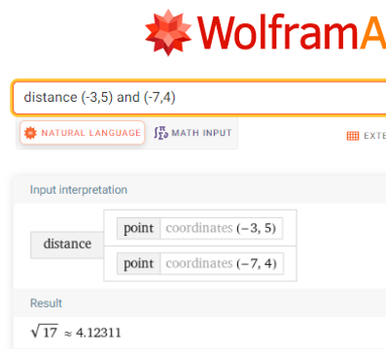

### THE EQUATION OF A CIRCLE AND A SPHERE

We can use the distance formulas to get equations of circles and spheres.

The center-radius form of a circle with center at the point and radius is

|  |  |
| --- | --- |
|  | Diagram showing use of distance formula to get equation of a circle with a point and radius. |

The center-radius form of a sphere with center at the point and radius is

|  |  |
| --- | --- |
|  | Diagram showing use of distance formula to get equation of a sphere with a point and radius. |

To write the equation of a circle that has as its center the point and radius 8,

Example (2)

we use the center-radius form with and .

To write the equation of a sphere that has as its center the point and radius

Example (3)

8, we use the center-radius form with

and .

### 3.1 TRY THESE

1. Find the distance between the two points and . Round to one decimal place.
2. Find distance between the two points and . Round to one decimal place.
3. Write the equation of a circle that has as its center the point and radius 1.

4.Write the equation of a sphere that has as its center the point and radius 4.

## 3.2 Magnitude and Direction Cosines of a Vector

### THE MAGNITUDE OF A VECTOR

You likely recall that the magnitude (the length) of a vectorin **2-dimensions** is

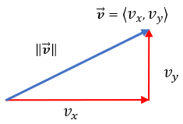

The vector has magnitude

Example (1)

=

Interpret this as the length of the vector is units.

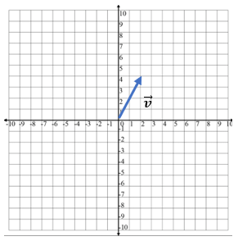

The formula for the length of the vector in **3-dimensions** is

The vector has magnitude

Example (2)

=

=

Interpret this as the length of the vector is units.

### THE DIRECTION COSINES OF VECTORS IN 2- AND 3-DIMENSIONS

The direction cosines of a vector or are the cosines of the angles the vector forms with the coordinate axes.

The direction cosines are important as they uniquely determine the direction of the vector.

Direction cosines are found by dividing each component of the vector by the magnitude (length) of the vector.

,

, ,

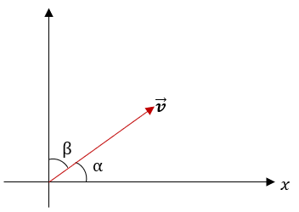 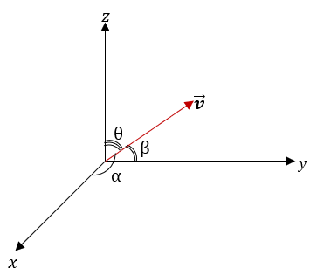

Find the direction cosines of the vector .

Example (3)

First, find the magnitude of the vector

Get the direction cosines by dividing each component, 4, 5, and 2, by this magnitude.

Find the vector that has magnitude 32 and direction cosines

Example (4)

and.

Since ,

, and

.

So, .

### USING TECHNOLOGY

We can use technology to determine the magnitude of a vector.

Go to www.wolframalpha.com.

To find the magnitude of the vector enter magnitude of <2, 4, -6> in the entry field. Wolframalpha tells you what it thinks you entered, then tells you its answer. In this case, .

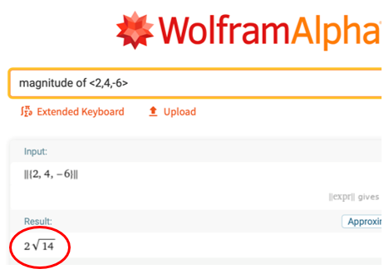

To find the direction cosines of the vector enter evaluate 4/(magnitude of <4,5,2>), 5/(magnitude of <4,5,2>), 2/(magnitude of <4,5,2>) in the entry field. WolframAlpha answers .

We can use WolframAlpha to approximate a vector give its magnitude and direction cosines.

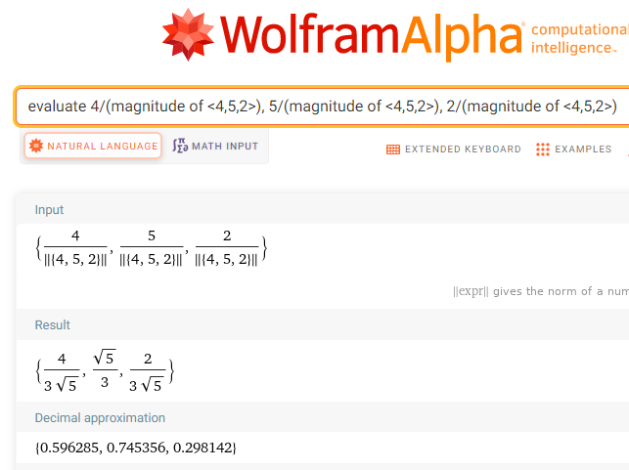

### 3.2 TRY THESE

1. Find the magnitude of the vector
2. Find the magnitude of the vector
3. Find the cosines of the vector . Round to three decimal places.
4. Approximate the vector that has magnitude 24 and direction cosines  
   .

## 3.3 Arithmetic on Vectors in 3-Dimensional Space

### ADDITION & SUBTRACTION OF VECTORS

To add or subtract two vectors, add or subtract their corresponding components.

To **add** the vectors and add their corresponding components.

Example (1)

So,

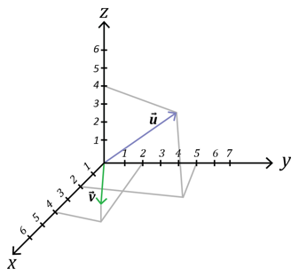

Now, graph this sum. Start at the origin.

Since the component is 6, move 6 units in the direction.

Since the component is, move 7 units in the direction.

Since the component is, move 5 units upward.

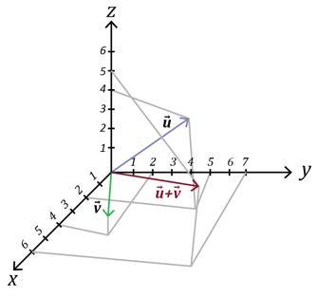

To **subtract** the vectors and subtract their corresponding components.

Example (2)

So,

### SCALAR MULTIPLICATION

Scalar multiplication is the multiplication of a vector by a real number (a scalar).

Suppose we let the letter represent a real number and be the vector Then, the scalar multiple of the vector is

Suppose and .

Example (1)

Then 3

Suppose and .

Example (2)

Then

Suppose , , and . Find

Example (3)

Then

### USING TECHNOLOGY

We can use technology to determine the value of adding or subtracting vectors.

Go to www.wolframalpha.com.

Suppose and , , and . Use WolframAlpha to find In the entry field enter evaluate 3*[-2,6,0] + 4*[1,2,-8] – 2*[-3,-1,2].

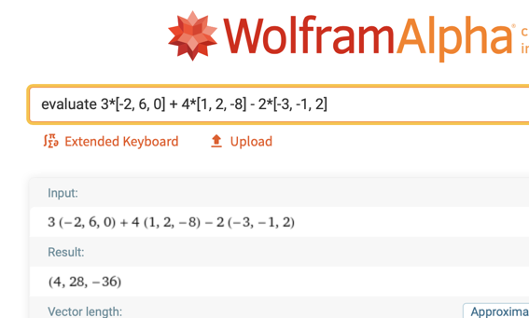

WolframAlpha answers which is WolframAlpha’s notation for .

### 3.3 TRY THESE

1. Add the vectors
2. Subtract the vector from the vector
3. Given the three vectors, , , and ,  
   find .
4. Suppose and , , and , find .

## 3.4 The Unit Vector in 3-Dimensions and Vectors in Standard Position

### THE UNIT VECTOR IN 3-DIMENSIONS

The unit vector, as you will likely remember, in 2-dimensions is a vector of length 1. A unit vector in the same direction as the vector is often denoted with a “hat” on it as in . We call this vector “v hat.”

The unit vector corresponding to the vector is defined to be

The unit vector corresponding to the vector is

Example (1)

A unit vector in 3-dimensions and in the same direction as the vector is defined in the same way as the unit vector in 2-dimensions.

The unit vector corresponding to the vector is defined to be , where

For example, the unit vector corresponding to the vector is

### VECTORS IN STANDARD POSITION

A vector with its initial point at the origin in a Cartesian coordinate system is said to be in *standard position*. A common notation for a unit vector in standard position uses the lowercase letters i, j, and k is to represent the unit vector in

the -direction with the vector , where , and

the -direction with the vector, where , and

the -direction with the vector , where .

The figure shows these three unit vectors.

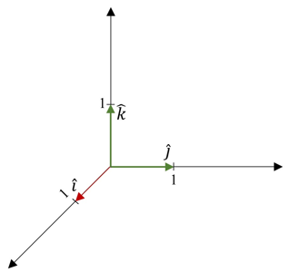

Any vector can be expressed as a combination of these three unit vectors.

The vector can be expressed as .

Example (2)

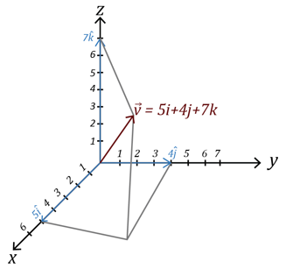

Now, the unit-vector in the direction of is

### NORMALIZING A VECTOR

Normalizing a vector is a common practice in mathematics and it also has practical applications in computer graphics.

Normalizing a vector is the process of identifying the unit vector of a vector .

### 3.4 TRY THESE

1. Write the unit vector that corresponds to
2. Write the unit vector that corresponds to .
3. Write the unit vector that corresponds to
4. Normalize the vector .

### USING TECHNOLOGY

We can use technology to find the unit vector in the direction of given vector.

Go to www.wolframalpha.com.

Use WolframAlpha to find the unit vector in the direction of . In the entry field enter normalize <5,4,3> and WolframAlpha gives you an answer.

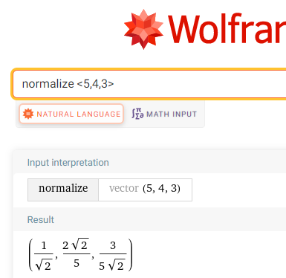

Translate WolframAlpha’s answer to .

## 3.5 The Dot Product, Length of a Vector, and the Angle between Two Vectors in Three Dimensions

### THE DOT PRODUCT OF TWO VECTORS

The dot product of two vectors and in two dimensions is nicely extended to three dimensions.

The dot product of vectors and

is a scalar (real number) and is defined to be

Since , and are real numbers, you can see that the dot product is itself a real number and not a vector.

To compute the dot product of the vectors and ,  
 we compute

Example (1)

Since the dot product is a scalar, it follows the properties of real numbers.

**PROPERTIES OF THE DOT PRODUCT**

1. , the dot product is commutative
2. , the dot product distributes over vector addition
3. , the dot product with the zero vector, is the scalar 0.

Compute the dot product , where

Example (2)

, , and ,

### THE LENGTH OF A VECTOR IN THREE DIMENSIONS

The length (magnitude) of a vector in two dimensions is nicely extended to three dimensions.

The dot product of a vector with itself gives the length of the vector.

You can see that the length of the vector is the square root of the sum of the squares of each of the vector’s components. The same is true for the length of a vector in three dimensions.

The dot product of a vector with itself gives the length of the vector.

Use the dot product to find the length of the vector .

Example (3)

In this case, , and

Using , we get

The length of the vector is units.

### THE ANGLE BETWEEN TWO VECTORS

The formula for the angle between two vectors in two dimensions is nicely extended to three dimensions.

If is the smallest nonnegative angle between two non-zero vectors and , then

or

where and and

Find the angle between the vectors and .

Example (4)

Using , we get

We conclude that the angle between these two vectors is close to 85.7° rounded to one decimal place.

### USING TECHNOLOGY

We can use technology to find the magnitude of the vector and the angle between two vectors.

Go to www.wolframalpha.com.

To find the magnitude (length) of the vector enter magnitude of <4, 2, 6> in the entry field. Wolframalpha tells you what it thinks you entered, then tells you its answer. In this case, .

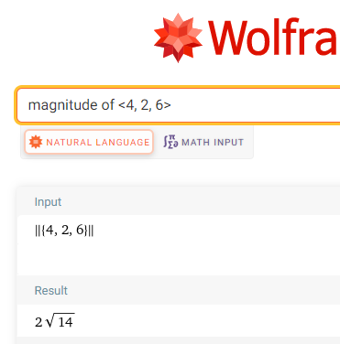

To find the angle between the vectors and **,** enter angle between the vector <5, -3, -1> and <2, 4, -5> in the entry field. Wolframalpha tells you what it thinks you entered, then tells you its answer. In this case, , rounded to one decimal place.

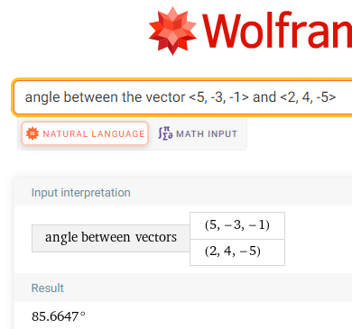

### 3.5 TRY THESE

1. Find the dot product of the vectors and .
2. Find the dot product of the vectors and .

1. Find the length of the vector .

4.Find the length of the vector .

5.Find the angle between the vectors and .

6.Find the angle between the vectors and .

## 3.6 The Cross Product: Algebra

### THE CROSS PRODUCT OF TWO VECTORS

A vector that is perpendicular to both vectors and , can be found using the cross product. The cross product requires that both vectors be in three-dimensional space.

The cross product of vectors and is a vector and is defined to be

This formula is challenging to remember. A nice device to help you remember both this formula and the dot product formula is to visualize them in a 3x3 square of components. The square shows how vectors can interact with one another.

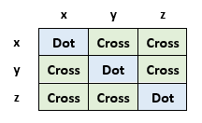

For the cross product,

The -component has a product that involves no -components:

The -component has a product that involves no -components:

The -component has a product that involves no -components:

Each component is a difference of two diagonal products.

|  |  |
| --- | --- |
| Table showing a 3x3 square of components with examples of cross products. | To produce the -component,  (top right) - (bottom left) = y*z – z*y  To produce the -component,  (bottom left) - (top right) = z*x – x*z  To produce the -component,  (top right) – (bottom left) = x*y – y*x |

The **DOT** product is the interaction between two vectors having **similar** components:

The dot product measures similarity since it combines only interactions of matching components.

The **CROSS** product is the interaction between two vectors having **different** components:

The cross product measures cross interactions since it combines interactions of different components.

Find the cross product of the vectors and .

Example (1)

|  |  |
| --- | --- |
| 3x3 square table of components with calculations for finding a cross product of the two vectors. | 3x3 square table of components with results of a cross product of the two vectors. |

To produce the -component, (top right) - (bottom left) = 2*(-7) – 4*4 = -30

To produce the -component, (bottom left) - (top right) = 4*3 – 5*(-7) = 47

To produce the -component, (top right) – (bottom left) = 5*4 – 2*3 = 14

*Be careful with the computation. It goes (bottom left) – (top right) while  
the first and last go (top right) – (bottom left).

### USING TECHNOLOGY

We can use technology to find the cross product between two vectors.

Go to www.wolframalpha.com.

To find the cross product of the vectors and use either the “cross” or the x command. Wolframalpha tells you what it thinks you entered, then it tells you its answer. In this case, .

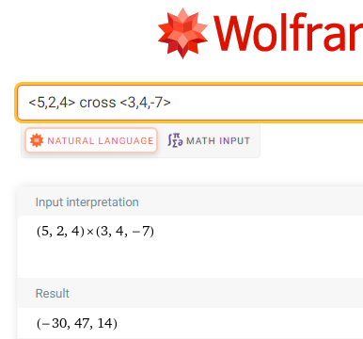

### THE RIGHT-HAND RULE

You can see that the cross product of the two vectors and , is itself a vector. But where is this vector The cross product of two vectors is a vector that is perpendicular to the plane formed by the two vectors. What about the two perpendicular directions? Does this perpendicular vector lie above or below the plane formed by the two vectors? We use the **right-hand rule**.

Hold your hand as shown in the picture, your index and middle fingers extended. Your thumb points in the direction of the cross product.

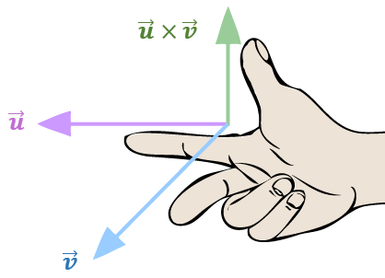

Since the dot product is a scalar, it follows the properties of real numbers.

**PROPERTIES OF THE CROSS PRODUCT**

1. , the cross product is **anti-commutative**
2. , the cross product distributes over vector addition
3. =
4. , the cross product with the zero vector, is the zero vector,

### USING TECHNOLOGY

For example, use WolframAlpha to compute both the cross product and , where

, and to show one is the opposite of the other.

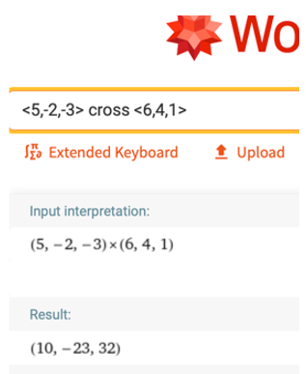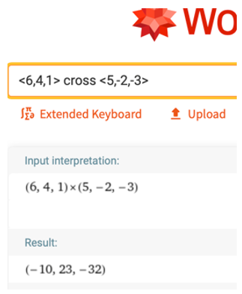

Notice that , verifying property 1.

### 3.6 TRY THESE

1. Find the cross product of the vectors and .
2. Find the cross product of the vectors and .
3. Find , where , , and .

* Note that the cross product must be computed first since if it is not, we would be crossing a vector with a scalar.

## 3.7 The Cross Product: Geometry

### THE CROSS PRODUCT OF TWO VECTORS AND THE RIGHT-HAND RULE

The cross product of the two vectors and , is itself a vector. Where is this vector The cross product of two vectors is a vector perpendicular to the plane formed by the two vectors. What if there are two perpendicular directions? Does this perpendicular vector lie above or below the plane formed by the two vectors? Let’s use the **right-hand rule**.



Hold your hand as shown in the picture, your index and middle fingers extended. Your thumb points in the direction of the cross product.

### THE GEOMETRY OF THE CROSS PRODUCT

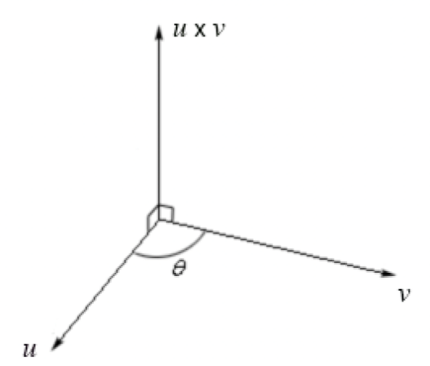

If is the angle between the two vectors and , then the length (magnitude) of the cross product is

and

The length of the vector , where and is

Example (1)

We now need to get . We’ll use the formula for the angle between two vectors.

Now we compute units.

### USING TECHNOLOGY

We can use technology to find the magnitude of the cross product of two vectors.

Go to www.wolframalpha.com.

To find the length of the cross product of the vectors and enter magnitude of <5,2,4> cross <3,4,-7>in the entry field.Wolframalpha tells you what it thinks you entered and its answer. In this case it shows you result of . Click on the approximate form button to get the result in decimal form as .

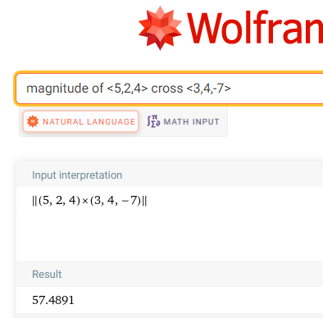

### AREA OF A PARALLELOGRAM

Geometrically, produces the area of a parallelogram determined by and .

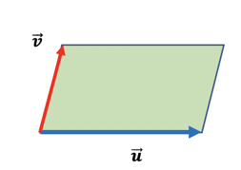

Area =

For example, the area of the parallelogram determined by the vectors and  
 is 57.49 square units.

### THE CROSS PRODUCT OF PERPENDICULAR AND PARALLEL VECTORS

If vectors and are *perpendicular* to each other, then the angle between them is 90° and , so that

If vectors and are *parallel* to each other, then the angle between them is 0° and

It makes sense then to define the cross product of parallel vectors to be the zero vector, . Also, if at least one of the vectors and is the zero vector, then the cross product is defined to be the zero vector. We can say that if the cross product of two vectors is zero, then the vectors are parallel to each other. Also, if two vectors are parallel to each other, then their cross product is zero. We combine these statements together in an *if-and-only-if* statement.

Nonzero vectors and are parallel to each other if and only if .

**PROPERTIES OF THE CROSS PRODUCT**

1. , the cross product is **anti-commutative**
2. , multiplication by a scalar
3. , the cross product distributes over vector addition
4. , the cross product with the zero vector, zero vector, .

Use WolframAlpha to verify that

Example (2)

where , , and .

Use W|A to first compute and then . Determine if the results do or do not match. We can do this in one step by entering

<5,-2,-3> x (<6,4,1> + <-3,7,2>) = <5,-2,-3> x <6,4,1> + <5,-2,-3> x <-3,7,2>

If the statement on the left of the = equals the statement on the right, W|A responds with True.

If the statement on the left of the ≠ equals the statement on the right, W|A responds with False.

In this case, we get a True response and have verified the truth of the statement.

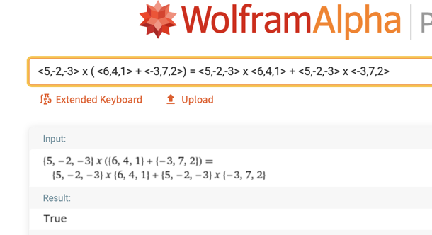

### 3.7 TRY THESE

1. Find the cross product of the vectors and .
2. Find the cross product of the vectors and .
3. Find the length of the vector formed by the cross product of the of the vectors  
    and .
4. Find the angle between the vectors and .
5. Determine if the vectors and are perpendicular or parallel to each other.
6. Find the area of the parallelogram and the triangle formed by the vectors

and .

# UNIT 4 MATRICES

## 4.1 Matrices

### MATRIX

A matrix is a rectangular array of objects, often, numbers.

The rectangular array of numbers is a matrix having 3 rows and 2 columns.

Example (1)

### DIMENSION OF A MATRIX

Matrices having number of rows and number of columns has dimension (size) (pronounced as "m by n") and is called an matrix.

The matrix in Example 1 is a matrix since it is composed of 3 rows and 2 columns. When specifying the dimension of a matrix, the number of rows is stated first and the number of columns second.

### ELEMENTS OF A MATRIX

It is common to use an uppercase letter of the alphabet to name a matrix and the corresponding lowercase letter to name an element (entry or member) of the matrix. Subscripts are attached to the lowercase letter to specify its position in the matrix.

The first number in subscript indicates the row in which the element resides  
and the second number the column.

The subscript numbers appear adjacent to each other and typically without a comma separating them.

We could name the matrix of Example 1 with the uppercase letter and write .  
  
We specify the element in row 1, column 2, with the notation . The lowercase is used to indicate that the element is from matrix and the subscripts to indicate we are observing the entry in row 1, column 2. The subscript is not the number 12, but rather the two individual numbers, 1 and 2.

Some other elements of are

In general, the notation denotes the entry in row and column

the number in row 1, column 1

the number in row 3, column 1

the number in row 2, column 2

In general, an matrix has the form . For some number , the element is the number in row , column 2.

##### TRY THESE

In the matrix

1. Specify the size of .
2. Find the value of
3. Find the value of
4. Find the value of

ANS: (a) , (b) 0, (c) 2, (d) 3

### EQUAL MATRICES

Two matrices and are said to be equal, written as , if they are the same size and all the corresponding entries are equal.

In matrix notation, for all and , if The notation names the element in row and column of matrix . Similarly, the notation names the element in row and column of matrix . The notation indicates that the element in row and column of matrix is the same as the element in row and column of matrix

### SQUARE MATRICES

A matrix is called square if it has the same number of columns as rows.

The matrices and are both equal and square.

Example (2)

and

### MAIN DIAGONAL OF A SQUARE MATRIX

Consider a square matrix, say Imagine a line passing from the top left element to the bottom right element as in the picture.

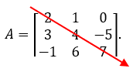

This diagonal set of elements from the top left element to the bottom right is called the main diagonal of the matrix.

##### DIAGONAL AND NON-DIAGONAL ELEMENTS OF A MATRIX

The elements lying on the main diagonal of matrix are called the diagonal elements of matrix . The elements 2, 4, and 7 the diagonal elements of matrix . The elements lying off the main diagonal of matrix called the non-diagonal or off-diagonal elements of matrix . The elements and are the non-diagonal elements of matrix .

### THE IDENTITY MATRIX

An Identity matrix is a square matrix that has only 1’s on its main diagonal and 0’s everywhere else.

That is, a matrix in which every diagonal element is 1 and every non-diagonal element is 0 is an identity matrix. Identity matrices are typically named with the uppercase letter It is not uncommon to write the size of the matrix as a subscript on the

The square matrix is the . We could write to indicate the identity matrix.

Example (3)

### THE ZERO MATRIX

The zero matrix is a matrix, in which every element is 0.

Zero matrices are commonly named with a 0.

The matrix is a zero matrix.

Example (4)

### THE TRANSPOSE OF A MATRIX

Consider some matrix For example, suppose is the matrix .  
Form a new matrix, call it -transpose and denote it by , by making

* The first row of the first column of ,
* The second row of the second column of .

Then is the transpose of .

The rows of a matrix are the columns of its transpose. If the matrix is size ,  
then dimension of is .

### ROW MATRICES AND COLUMN MATRICES

A row matrix is a matrix with only one row and any number of columns.

The matrix is a row matrix with 3 columns. It is a matrix.

A column matrix is a matrix with only one column and any number of rows.

The matrix is a column matrix with 2 rows. It is a matrix.

### VECTORS AS MATRICES

When we first described vectors, we expressed them using the bracket notation. For example, we could write a vector as . We can just as easily describe this vector using a row matrix or column matrix

### 4.1 TRY THESE

1. Specify the dimension of each matrix.
2. True or False: The transpose of a square matrix is also a square matrix.
3. In the matrix specify
   1. Find the value of
   2. Find the value of
   3. Find the value of
   4. Find the value of
4. Construct and name the transpose of .
5. Construct
6. Construct the transpose of
7. Write the column matrix using vector bracket notation, < >.
8. Construct a matrix in which the diagonal elements are 5 and 6 and the non-diagonal elements are 0 and 2.

## 4.2 Addition, Subtraction, Scalar Multiplication, and Products of Row and Column Matrices

### Addition and Subtraction of Matrices

Let and be matrices. Then the sum, , is the new matrix formed by adding corresponding entries together. The difference, , is the new matrix formed by subtracting each entry in matrix from its corresponding entry in matrix .

To add or subtract two or more matrices together, they all must be of the same size. That is, they all have to have the same number of rows and the same numbers of columns. To add them together, add the corresponding elements together. To subtract one from the other, subtract corresponding elements together from each other.

If the addition and subtraction is defined (if it is possible), perform each operation.

Example (1)

is not defined as they are different sizes. Matrix is a matrix whereas matrix is a matrix.

TRY THIS: Compute

### Scalar Multiplication

You might recall that a scalar is a physical quantity that is defined by only its magnitude and that some examples are speed, time, distance, density, and temperature. They are represented by real numbers (both positive and negative), and they can be operated on using the regular laws of algebra.

To multiply a matrix by a scalar, multiply every element of the matrix by the scalar.

Symbolically,

Example (2)

TRY THIS:

### Multiplication with Row and Column Matrices

Suppose we have two matrices, and where is a matrix and is an matrix. That is, has one row and columns and has rows and only 1 column.

and

The product is the new matrix obtained by multiplying together the corresponding elements of each matrix then adding those sums together.

This product is the sum (addition) of the

first entry in times the first entry in

second entry in times the second entry in

last entry in times the last entry in

Suppose and . Then,

Example (3)

Notice the dimensions of the two matrices. The number of rows of is 3 which is equal to the number of columns of which is also 3. The product is a matrix whose dimension is the

(number of rows of (number of columns of ).

TRY THIS: Suppose and . Show that

### Motivation for the Process of Multiplication with Row and Column Matrices

This process of multiplication may not seem intuitive; however, we can motivate it with an example. You probably know, or at least believe, that the revenue realized by selling number of units of some product for dollars per unit is given by . Revenue equals (the number of units sold) times the (price of each unit).

Suppose your business sells three sizes of boxes, small-sized boxes, medium-sized boxes, and large-sized boxes. Small boxes sell for $3 each, medium boxes for $5 each, and large boxes for $7 each. What would your total revenue be if you sold 20 small-sized boxes, 30 medium-sized boxes, and 40 large-sized boxes?

Example (4)

Using , your revenue from the sale of the

small boxes is

medium boxes is

large boxes is

The total revenue is the sum of these three products,

We can compute the total revenue using two matrices and matrix multiplication.

Let the first matrix be the row matrix of the number of boxes sold,

and the second matrix be the column matrix of the number of boxes sold.

The total revenue is the matrix product .

### Important Observation – See this

Notice that the result of a row and column matrix multiplication is a matrix with exactly one entry. That entry is the sum of a collection of products. In Example 4, the result of the row and column matrix multiplication is a matrix with exactly one entry, $490. The $490 is the sum of the products , and Don’t let the phrase the sum of a collection of products befuddle you. It means it is the addition (the sum) of a collection of multiplications (products). This idea will be helpful in the next section when we discuss multiplication of matrices of larger dimensions.

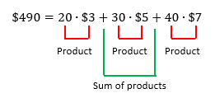

### Dimension Matters

Notice the dimensions of the two matrices and from Example 4. The number of rows of is 3, which is equal to the number columns of which is also 3. The product is a matrix whose dimension is (the number of rows of (the number of columns of ).

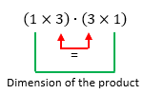

To multiply a row matrix and column matrix together, it must be that the

(number of rows of (number of columns of

Symbolically, if has number of columns, must have number of rows

Suppose and .

Example (5)

This multiplication will not work, it is not defined. Matrix has 4 rows, but has only 3 columns.

=

### 4.2 Try these

Using these six matrices, perform each operation if it is defined (if it is possible).



## 4.3 Matrix Multiplication

### Compatible Matrices

We are going to multiply together two matrices, one of size , and one of size . The multiplication will be possible, and the product exists because the sizes make them compatible with each other.

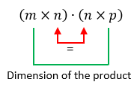

Notice the number of columns of the leftmost matrix is equal to the number of rows of the rightmost matrix.

For the product, of two matrices to exist it must be that

(the number of columns of matrix ) = (the number of rows of matrix )

Matrices for which this is true are said to be compatible with each other.

### Matrices as Collections of Row and Column Matrices

It is productive to think of a matrix as a collection of individual row matrices and column matrices.  
For example, we can think of the matrix as being composed of

* the three row matrices, and and
* the two column matrices and .  
  (If you need a review of row and column matrices, see Section 4.2)

### Multiplication of Two Matrices

To multiply two compatible matrices and together, multiply  
every row matrix of through every column matrix of .

Suppose the size of matrix is and the size of matrix is . The matrices are compatible with each other and the size of the product is

Some of the entries of the product are

: The entry in row 1, column 1, is the result of multiplying the

1st row of matrix through the 1st column of matrix .

: The entry in row 1, column 2, is the result of multiplying the

1st row of matrix through the 2nd column of matrix .

: The entry in row 2, column 4, is the result of multiplying the

2nd row of matrix through the 4th column of matrix .

: The entry in row 3, column , is the result of multiplying the

3rd row of matrix through the 5th column of matrix .

: The entry in row 3, column 3, is the result of multiplying the

3rd row of matrix through the 3rd column of matrix .

Do you see the general rule for producing any particular entry?

To get the entry in row and column, multiply

the row of matrix through the column of matrix

Compute the product of the matrices and .

Example (1)

Note first that the two matrices are compatible

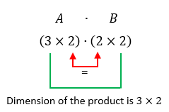

The product is the matrix of the form

Since we are multiplying 3 rows through 2 columns, there will be 6 entries. The six entries of are

the 1st row of times the 1st column of

= =

the 1st row of times the 2nd column of

= =

the 2nd row of times the 1st column of

= =

the 2nd row of times the 2nd column of

= =

the 3rd row of times the 1st column of

= =

the 3rd row of times the 2nd column of

= =

So,

TRY THIS: Show that the product of the matrices and is .

### Using Technology

You can see that multiplying matrices together involves a lot of arithmetic and can be cumbersome. We can use technology to help us through the process.

Go to www.wolframalpha.com.

To find the product of the two matrices of above Try This Example, enter [ [2,3], [4,1] ] * [ [2,3,0], [1,2,4] ] in the entry field. WolframAlpha sees a matrix as a collection of row matrices.

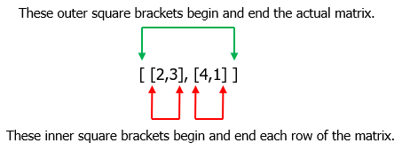

Both entries and rows are separated by commas and W|A does not see spaces.

Wolframalpha tells you what it thinks you entered, then tells you its answer .

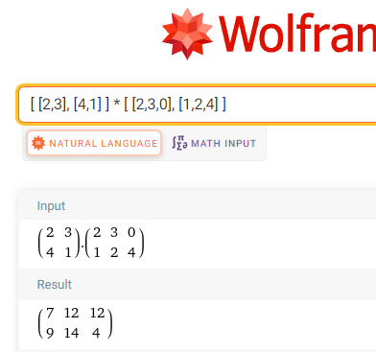

### 4.3 Try these

Perform each multiplication if it is defined. If it is not defined, write "not defined."

1. Compare your answers to question 1 and 2. If you got them right, would you say that matrix multiplication is or is not commutative?

## 4.4 Rotation Matrices in 2-Dimensions

### The Rotation Matrix

To this point, we worked with vectors and with matrices. Now, we will put them together to see how to use a matrix multiplication to rotate a vector in the counterclockwise direction through some angle in 2-dimensions.

|  |  |
| --- | --- |
| Diagram of a vector v in a coordinate system and its counterclockwise rotation through some angle. | Diagram of a vector v and its rotational  vector v prime. Vector v is rotated counterclockwise through an angle and v prime is new vector after the rotation. |

Our plan is to rotate the vector counterclockwise through some angle to the new position given by the vector . To do so, we use the rotation matrix, a matrix that rotates points in the -plane counterclockwise through an angle relative to the -axis.

### The Rotation Process

To get the coordinates of the new vector perform the matrix multiplication

Find the vector that results when the vector is rotated 90° counterclockwise.

Example (1)

Using the rotation formula with

and we get

When rotated counterclockwise 90°, the vector becomes .

|  |  |
| --- | --- |
| Diagram showing vector (1,-1). | Diagram showing vector (1,-1) and a new vector (1,1) after vector (1,-1) is rotated counterclockwise through 90 degrees. |

Find the vector that results when the vector is rotated 60° counterclockwise.

Example (2)

Using the rotation formula with and we get

When rotated counterclockwise 60°, the vector becomes .

|  |  |
| --- | --- |
| Diagram showing vector (2,6). | Diagram showing vector (2,6) and a new vector (-4.20,4.73) after vector (2,6) is rotated counterclockwise 60 degrees. |

### Using Technology

We can use technology to help us find the rotation. WolframAlpha evaluates the trig functions for us.

Go to www.wolframalpha.com.

We can check the above problem from Example 2 by using WolframAlpha. Find the vector that results when the vector is rotated 60° counterclockwise.

To find rotation of the vector enter Evaluate [ [cos(60), –sin(60)], [sin(60), cos(60)] ] * [ 2,6 ] into the entry field. Both entries and rows are separated by commas and W|A does not see spaces.

WolframAlpha tells you what it thinks you entered, then it shows you the answer.

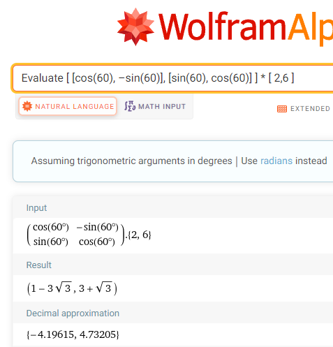

When rotated counterclockwise 60°, the vector becomes

### 4.4 Try these

1. through 90°.
2. through 180°.
3. through 270°.
4. through 90°.
5. through 45°.
6. through 45°.
7. through °.
8. through °.
9. Approximate, to five decimal places, the coordinates of the vector when it is rotated counterclockwise 30°.

## 4.5 Finding the Angle of Rotation Between Two Rotated Vectors in 2-Dimensions

### Given the Rotated Vector, Find the Angle of Rotation

Suppose we did not know the angle of rotation. We can get it by working backwards and solving a system of equations. The rotation formula

produces the system of equations

In Example 1 of Chapter 4.4, we found that when the vector was rotated counterclockwise by 90°, it became the vector . We got this rotated vector by applying the rotation formula

Example (1)

Since two vectors are equal only if their corresponding components are equal, we have the system of two equations

### Using Technology

We can use WolframAlpha to help us solve above system for the angle of rotation,

Go to www.wolframalpha.com.

Since we want to rotate only one time around the coordinate system, we want to instruct W|A to give us solutions only where the angle is between 0 and 2.

Using the English letter x in place of the Greek letter enter

Solve 1 = 1*cos(x) + (-1)*(-sin(x)), 1 = 1*sin(x) + (-1)*cos(x), 0 <= x <= 2*pi in the entry field.

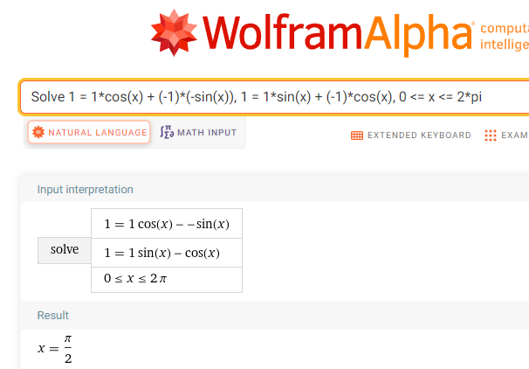

W|A shows the angle of rotation is , which is 90°. We conclude that the angle of rotation is 90°.

In Example 2 of Chapter 4.4, we found that when the vector was rotated counterclockwise by 60°, it became the vector . We got this rotated vector by applying the rotation formula

Example (2)

Since two vectors are equal only if their corresponding components are equal, we have the system of two equations

We will use WolframAlpha to help us solve this system for the angle of rotation,

Using the English letter x in place of the Greek letter enter

Solve 1 – 3sqrt(3) = 2*cos(x) + 6*(–sin(x)), 3 + sqrt(3) = 2*sin(x) + 6*cos(x), 0 <= x <= 2*pi

in the entry field. Separate the two equations with a comma.

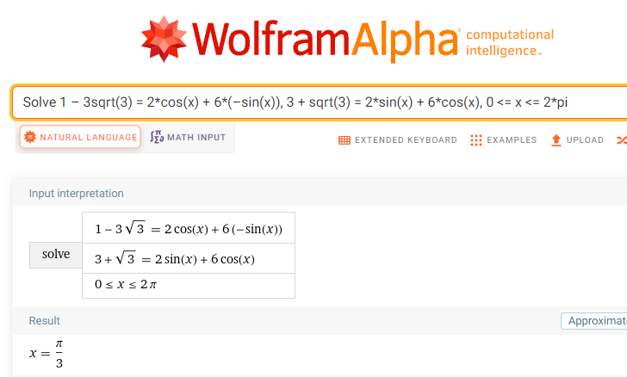

W|A shows the angle of rotation is , which is 60°. We conclude that the angle of rotation is 60°.

### 4.5 Try these

1. Find the angle through which the vector is rotated to become .
2. Find the angle through which the vector is rotated to become .

1. Find the angle through which the vector is rotated to become .
2. Find the angle through which the vector is rotated to become .
3. Find the angle through which the vector is rotated to become .

## 4.6 Rotation Matrices in 3-Dimensions

### The Three Basic Rotations

A basic rotation of a vector in 3-dimensions is a rotation around one of the coordinate axes. We can rotate a vector counterclockwise through an angle around the–axis, the –axis, or the –axis.

To get a counterclockwise view, imagine looking at an axis straight on toward the origin.

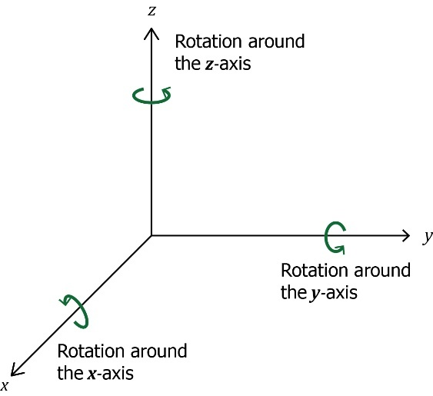

Our plan is to rotate the vector counterclockwise around one of the axes through some angle to the new position given by the vector . To do so, we will use one of three rotation matrices.

### The Rotation Matrices

The rotation matrices for , , and axes are, respectively,

### The Rotation Process

To rotate the vector counterclockwise through an angle around the –axis to a new position perform the matrix multiplication,

##### The –axis

To rotate the vector counterclockwise through an angle around the –axis to a new position perform the matrix multiplication,

##### The –axis

To rotate the vector counterclockwise through an angle around the –axis to a new position perform the matrix multiplication,

##### The –axis

Find the vector that results when the vector is rotated 90° counterclockwise around –axis.

Example (1)

Using the rotation formula with and we get

When rotated counterclockwise 90° around the –axis, the vector becomes .

### Using Technology

We can use technology to help us find the rotation. WolframAlpha evaluates the trig functions for us.

Go to www.wolframalpha.com.

In Example 1, we rotated the vector 90° around the –axis to get

Example (2)

Now we will use WolframAlpha to rotate vector 90° around the –axis. We use the–axis rotation matrix .

To perform the rotation, enter Evaluate [ [cos(90),0,sin(90)], [0,1,0], [–sin(90),0,cos(90)] ] * [1,2,3] into the entry field.

Both entries and rows are separated by commas as W|A does not see spaces.

Wolframalpha tells you what it thinks you entered, then tells you its answer.

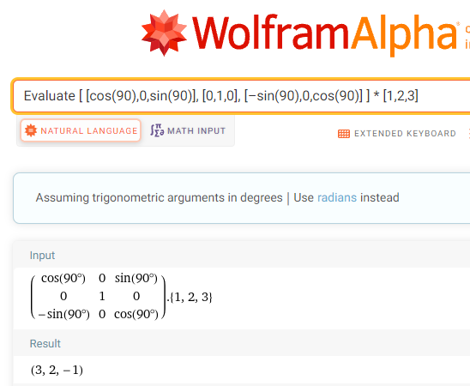

When rotated counterclockwise 90° around the –axis, the vector becomes .

Find the vector that results when the vector is rotated 45° counterclockwise around the –axis.

Example (3)

Since we are rotating the vector around the –axis, we use the –axis rotation

matrix .

Using WolframAlpha with and we get

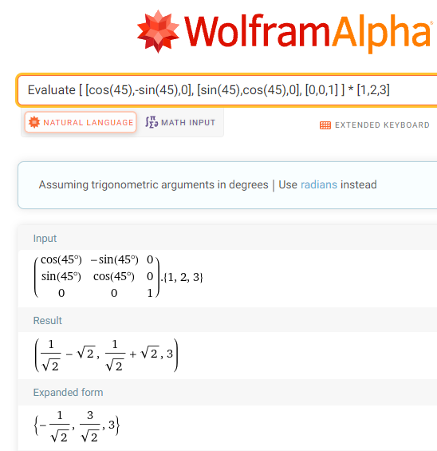

When rotated counterclockwise 45° around the –axis, the vector becomes .

### 4.6 Try these

Find the vector that results when the given vector is rotated the given angle counterclockwise around the given axis.

1. through 90° around the –axis.
2. through 45° around the –axis.
3. through 30° around the –axis.

# UNIT 5 SOME BASIC TRIGONOMETRY

## 5.1 The Basic Trigonometric Functions

### Right Triangle Trigonometry

There are six trigonometric functions associated with right triangles. Since our focus is on the mathematics of games, we will concentrate on only three of them, the sine function, the cosine function, and the tangent function.

The sine function is useful for producing the vertical motion of an object and the cosine function for producing the horizontal motion.

The figures just below show right triangles with angle , and sides opposite angle adjacent to angle , and the hypotenuse of the triangle

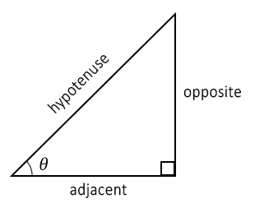 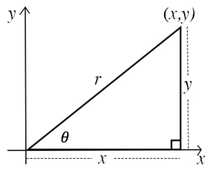

The angle has two measures associated with it:

1. Its degree measure, which we can label , and
2. Its trigonometric measure.

A trigonometric measure of an angle is a ratio (quotient) of two of the sides of the triangle.

We will discuss all three of these ratios, the sine, the cosine, and the tangent of an angle.

### The Sine of an Angle

In words: In a right triangle, the *sine* of angle is the ratio of the length of the side opposite to the length of the hypotenuse. We abbreviate the phrase “the *sine* of angle ” with .

Then, . That is .

### The Cosine of an Angle

In words: In a right triangle, the *cosine* of angle is the ratio of the length of the side adjacent to to the length of the hypotenuse. We abbreviate the phrase “the *cosine* of angle ” with .

Then, . That is cos.

### The tangent of an Angle

In words: In a right triangle, the *tangent* of angle is the ratio of the length of the side opposite to the length of the side adjacent to . We abbreviate the phrase “the *tangent* of angle ” with .

Then, . That is .

Find , cosand for the 3-4-5 triangle.

Example (1)

|  |  |
| --- | --- |
|  | Right triangle with angle theta and sides 3, 4, and 5. |

Find , cosand for the triangle.

Example (2)

|  |  |
| --- | --- |
|  | Right triangle with angle theta and sides 1, 1, and square root 2. |

### Using Technology

WolframAlpha evaluates the sines, cosines, and tangents of angles for us.

Go to www.wolframalpha.com.

Find , cos and .

Example (3)

To compute these ratios, enter Evaluate sin(45), cos(45), tan(45) into the entry field.

Separate the entries with commas. W|A does not see spaces.

WolframAlpha tells you what it thinks you entered, then tells you its answers.

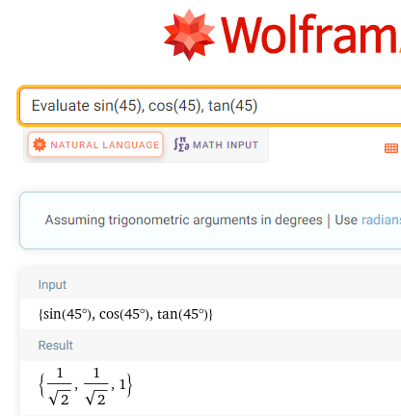

We conclude that , , and .

W|A also provides us with decimal approximations to these ratios.

, , and

Notice that these are the same values we got in Example 2.

Find

Example (4)

To compute these ratios, enter Evaluate sin(30), sin(60), sin(90) into the entry field.

Separate the entries with commas. W|A does not see spaces.

WolframAlpha tells you what it thinks you entered, then tells you its answers.

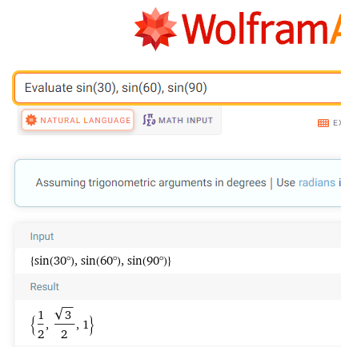

We conclude that and.

W|A also provides us with decimal approximations to these ratios.

and.

### 5.1 Try these

1. Find , cos, and tan for each triangle. Write your answers as decimal numbers rounded to 4 places.

|  |  |  |
| --- | --- | --- |
| a) | b) | c) |
| Right triangle with sides 1, 2, and square root 2 with an angle 45 degree. | Right triangle with angle theta and sides 3, 4, and 5. | Right triangle with angle theta and sides 2, 3, and square root 5. |
| d) | e) |  |
| Right triangle with angle theta and sides 1, 2, and square root 5. | Right triangle with angle theta and sides 8, 15, and square root 17. |  |

1. Find each value. Write your answers as decimal numbers rounded to 4 places.

a) , cos, tan

b) , cos

c) , cos, tan

d) , cos

e) , cos

## 5.2 Circular Trigonometry

### The Sine Function on the Unit Circle

In computer games, objects typically move up-and-down and left-to-right. These movements can be produced using the sine and cosine functions.

Draw a circle with radius 1 unit and on its circumference, place a point, let’s call it .

The circle centered at the origin with radius 1 is called the unit-circle.

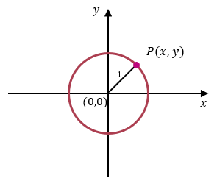

From our presentation of the sine and cosine function using right triangles, we can see that

That is, .

This tells us that the sine of the angle determines the vertical distance of the point from the horizontal axis.

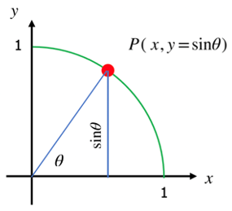

### The Cosine Function on the Unit Circle

To define cosine function, place a point on the circumference of unit-circle.

Once again, from our presentation of the cosine functions using right triangles, we can see that

That is, .

This tells us that the cosine of the angle determines the horizontal distance of the point from the vertical axis.

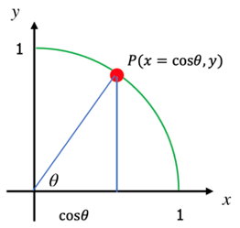

### The Sine and Cosine Functions on any Circle

We can extend this idea by making the radius of the circle units rather than just 1 unit.

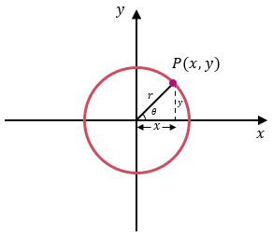

Using the same reasoning we just used with the unit circle, we see that

and

which, again, tells us that the sine of the angle determines the vertical distance of the point from the horizontal axis and that the cosine of the angle determines the horizontal distance of the point from the vertical axis.

If represents an object, that object’s height off the ground (the horizontal axis) is given by , and that object’s horizontal distance from some reference point is given by . The height of the object is controlled by some number times , and its horizontal distance is controlled by some number times .

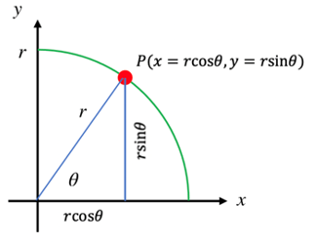

An object lies on the circumference of a unit circle. Find its coordinates if the line segment from the origin to the object makes angle of 30° with the horizontal.

Example (1)

|  |  |
| --- | --- |
| Because the object is on the circumference of unit circle, we can use  and , with , .    The coordinates of the object are (0.8660, 0.5). | Object P on unit circle with angle 30 degrees with the horizontal. |

An object lies on the circumference of a circle of radius 5 cm. Find its coordinates if the line segment from the origin to the object makes angle of 40° with the horizontal.

Example (2)

|  |  |
| --- | --- |
| Because the object is on the circumference of circle of radius 5 cm, we can use  and , with , .    The coordinates of the object are (3.8302, 3.2139). | Object P on circle of radius 5 centimeter with angle 40 degrees with the horizontal. |

The coordinates of an object are (2.1, 3.6373). Find its distance from the origin.

Example (3)

We can use the Pythagorean Theorem, , where is the hypotenuse, the radius of the circle in our case.

We conclude that the object is about 4.2 cm from the origin.

### 5.2 Try these

1. An object lies on the circumference of a unit circle. Find its coordinates if the line segment from the origin to the object makes angle of 45° with the horizontal.
2. An object lies on the circumference of a unit circle. Find its coordinates if the line segment from the origin to the object makes angle of 5° with the horizontal.
3. An object lies on the circumference of a circle of radius 25 cm. Find its coordinates if the line segment from the origin to the object makes angle of 75° with the horizontal.
4. An object lies on the circumference of a circle of radius 10 feet. Find its coordinates if the line segment from the origin to the object makes angle of 135° with the horizontal.
5. How high above the ground is an object that makes an angle of 60° with a 4-foot-tall observer’s eyes and is 35 feet away from that observer’s eyes? Round to two decimals place.

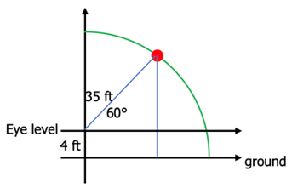

1. The coordinates of an object are (5.682, 2.0521). Find its distance from the origin if it makes an angle of 60° with the horizontal.

## 5.3 Graphs of the Sine Function

### Discrete Graph of the Sine Function from 0° to 90°

The graph of the sine function gives a visual illustration of how it determines the height of an object from a horizontal axis.

Imagine an object moving counterclockwise along the circumference of the unit circle. Start the object’s motion at the point (1, 0), then measure its height from the horizontal axis as its angle from origin increases from 0° to 90°.

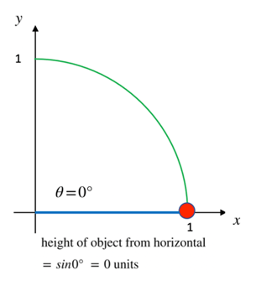 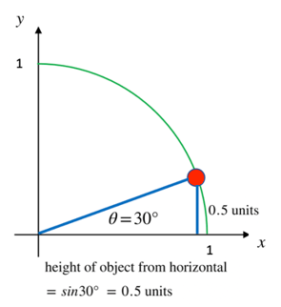

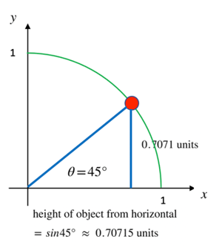 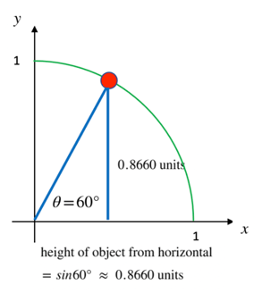

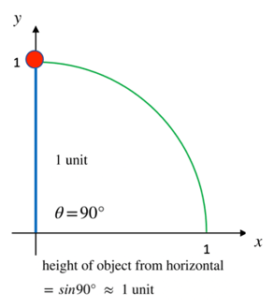

### Graphs of the Heights

If the angle is between 0° and 90°, the graph of the heights looks like this

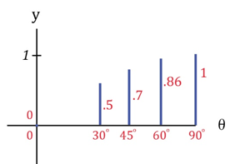

We can see that from 0° to 90°, as the angle from the observer to the object increases, the height of the object from the horizontal increases. That is, *the object moves vertically upward.*

If the angle goes past 90°, say all the way to 180°, the graph of the heights looks like this

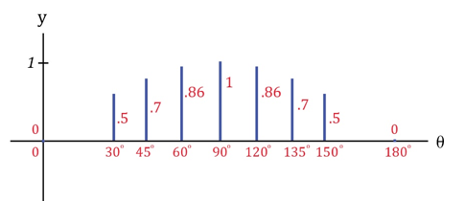

*The object moves vertically upward, then vertically downward.*

### The Continuous Sine Curve from 0° to 90°

If we plotted all the heights for all the infinitely many angles between 0° and 90°, we would get this continuous graph

Plotted heights for all the infinitely many angles zero degree to ninety degrees.
Plotted curve represent the continuous sine curve from 0 to 90 degrees.

for

### The Continuous Sine Curve from 0° to 180°

If we plotted all the heights for all the angles between 0° and 180°, we would get the continuous graph below

Plotted heights for all the infinitely many angles 0 degree to 180 degrees.
Plotted curve represents the continuous sine curve from 0 to 180 degrees.

for

### The Continuous Sine Curve from 0° to 360°

If we were to let the object travel all the way around the circle, we get the graph of the sine curve from 0° to 360°. You can see that when the angle is between 180° and 360°, the object is below the horizontal and may not be visible to an observer.

Plotted heights for all the infinitely many angles zero degree to 360 degrees.
Plotted curve represent the continuous sine curve from 0 to 360 degrees.

for

### The Extended Sine Curve

If we were to let the object keep travelling around the circle, we would see that the height of the curve just oscillates between –1 and 1.

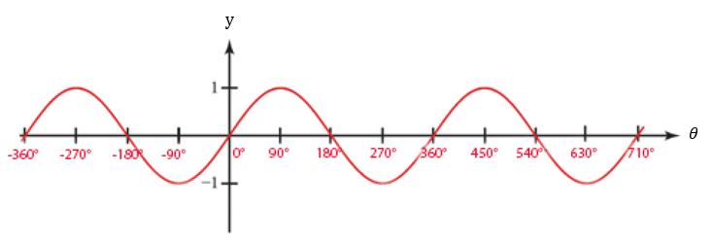

It may now be visually apparent that

The sine function controls the vertical distance of an object above or below the horizontal.

##### What to See

The graph shows how an object’s vertical distance from the horizontal changes as the angle of view increases. As the angle of view increases, the vertical distance from the horizontal increases and decreases.

##### What to Not See

The graph does not show how an object moves horizontally as the angle of view increases. The object is not moving up and down horizontally along the curve as time goes by. The horizontal axis is the angle of view, not time.

### 5.3 Try these

1. An object moves along the circumference of a unit circle. Find its height from the horizontal if the angle it makes from the origin is
   1. 225°
   2. 270°
   3. 315°
   4. 360°
2. An object moves along the circumference of a unit circle. Find its height from the horizontal if the angle it makes from the origin is
3. 390°
4. 405°
5. 420°
6. 450°
7. Determine if each statement is true or false.
8. Height at 87° > height at 78°
9. Height at 155° > height at 145°
10. Height at 30° height at 150°
11. Height at 90° height at 270°
12. Keeping in mind that the sine function determines vertical distance, and the cosine function determines horizontal distance, determine if each statement is true or false. The observer is at the origin.
13. Vertical height at 87° > horizontal distance at 87°
14. Vertical height at 155° > horizontal distance at 55°
15. Vertical height at 20° < horizontal distance at 20°
16. Vertical height at 135° = horizontal distance at 315°

## 5.4 Graphs of the Cosine Function

### Discrete Graph of the Cosine Function from 0° to 360°

Just as the sine function determines the vertical distance of an object from an observer, the cosine function determines the horizontal distance of an object from that observer.

Here is table of values for the cosine function for angles between 0° and 360° followed by a graph of the cosine function for all angles from 0° to 360°.

|  |  |
| --- | --- |
| Angle | Cosine  (Horizontal Distance from Observer) |
| 0° | 1 |
| 45° | 0.7071 |
| 90° | 0 |
| 135° | –0.7071 |
| 180° | –1 |
| 225° | –0.7071 |
| 270° | 0 |
| 315° | 0.7071 |
| 360° | 1 |

The positive cosine values indicate that the object is to the front of the observer whereas the negative values indicate that the object is to the back of the observer.

For example, at an angle of 45° from the observer’s eye, the object is 0.7071 units in front of the observer.

At an angle of 135° from the observer’s eye, the object is 0.7071 units behind the observer.

Plotted horizontal distances of object from the observer's eye for all the infinitely many angles from zero to 360 degrees.
Plotted curve represents the continuous cosine curve from 0 to 360 degrees.

If you think that this graph looks like the graph of the sine function, but shifted to the left by 90°, you would be right.

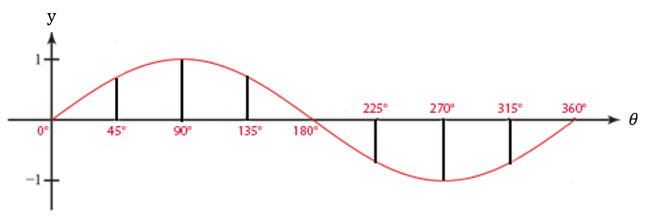

### The Extended Cosine Curve

Just as the sine curve does, the heights of the cosine curve oscillate between –1 and 1.

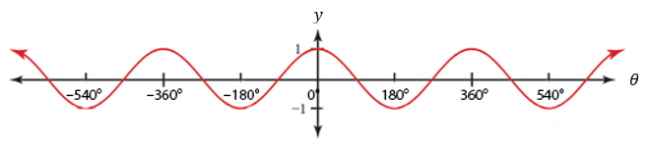

The graph of the cosine function gives a visual illustration of how it determines the horizontal distance of an object from a vertical axis.

It may now be visually apparent that

The cosine function determines the horizontal distance of an object to the left or right of an observer.

##### What to See

The graph shows how an object’s horizontal distance from the observer changes as the angle of view increases. As the angle of view increases, the horizontal distance from the vertical increases (moves away from the observer) and decreases (moves toward the observer).

##### What to Not See

The graph does not show how an object moves vertically as angle of view increases. The object is not moving along the curve.

### 5.4 Try these

1. An object moves along the circumference of a unit circle. Find its horizontal distance from an observer if the angle it makes from observer’s eye is

a. 225°

b. 270°

c. 315°

d. 360°

1. An object moves along the circumference of a unit circle. Find its horizontal distance from an observer if the angle it makes from observer’s eye is

a. 390°

b. 405°

c. 420°

d. 450°

1. Determine if each statement is true or false.
2. Horizontal distance at 87° > Horizontal distance at 78°
3. Horizontal distance at 45° > Horizontal distance at 145°
4. Horizontal distance at 30° Horizontal distance at 150°
5. Horizontal distance at 90° = Horizontal distance at 270°

## 5.5 Amplitude and Period of the Sine and Cosine Functions

### Amplitude

We have seen how the graphs of both the sine function, and the cosine function , oscillate between and . That is, the heights oscillate between –1 and 1.

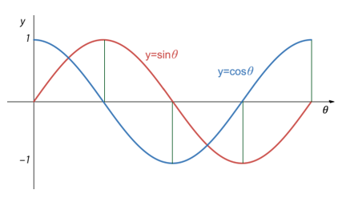

The height from the horizontal axis to the peak (or through) of a sine or cosine function is called

the **amplitude** of the function. Each of the curves and has amplitude 1.

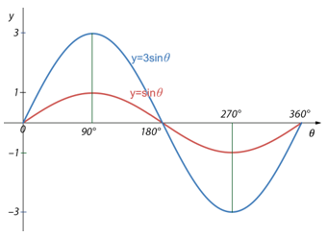

If we were to multiply the sine function  
by , getting ,  
each of the sine values would be multiplied by 3 making each value 3 times what it was. Each height would be tripled.  
The amplitude of is 3.

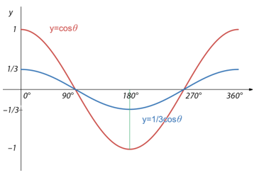

If we were to multiply the cosine function by , getting ,  
each of the cosine values would be multiplied by 1/3 making each value 1/3 of what it was. Each height of would be 1/3 of what it was.  
The amplitude of is 1/3.

### THE AMPLITUDE OF AND

Suppose represents a positive number. Then the **amplitude** of both and is and it represents height from the horizontal axis to the peak of the curve.

Examples

The amplitude of is 5/8. This means that the peak of the curve is 5/8 of a unit above the horizontal axis.

The amplitude of is 3. This means that the peak of the curve is 3 units above the horizontal axis.

### Period

Both the sine function and cosine function, and go through exactly one cycle from 0° to 360°. The **period** of the sine function and cosine functions, and is the “time” required for one complete cycle.

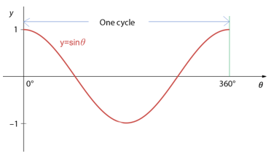 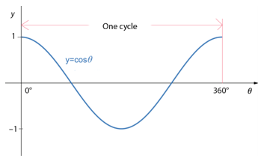

An interesting thing happens to the curves and when the angle is multiplied by some positive number, If the number is greater that 1, the number of cycles on 0° to 360° increases for both and . That is, the peaks of the curve are closer together, meaning their periods decrease. If the number is strictly between 0 and 1, the peaks of the curve are farther apart, meaning their periods increase.

### THE PERIOD OF AND

Suppose represents a positive number. Then the **period** of both and is As B gets bigger, gets smaller and the period increases.

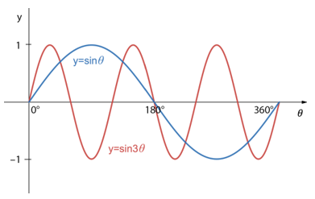

If we were to multiply the angle in the sine function by , getting , each of the angle’s values would be multiplied by 3 making each value 3 times what it was. Each angle would be tripled and there would be 3 cycles in the interval 0° to 360°.  
The period of is .  
The period of is smaller than that of .

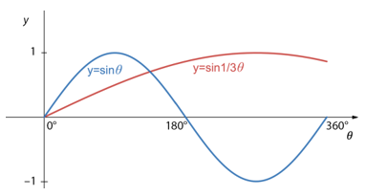

If we were to multiply the angle in the sine function by , getting Each of the angle’s values would be multiplied by 1/3 making each value 1/3 what it was and there would be only 1/3 of a cycle in the interval 0° to 360°.  
The period of  
 is = .  
The period of  
 is greater than that of

### Using Technology

We can use technology to help us construct the graph of a sine or cosine function.

Go to www.wolframalpha.com.

Plot two complete cycles of from 0° to 360°.

Example (1)

Type plot y = 6sin2x, x = 0..360 degrees in the entry field.

WolframAlpha tells you what it thinks you entered, then produces the graph.

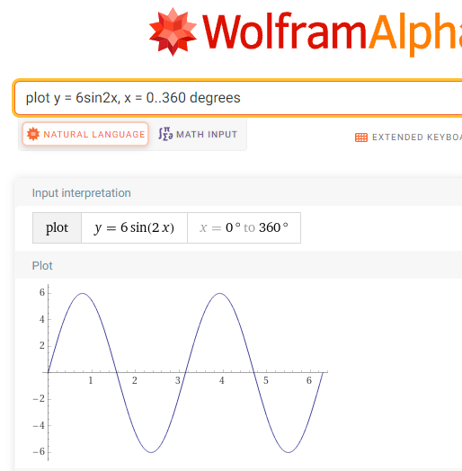

You can see that WolframAlpha has plotted two complete cycles from 0° to 360° with amplitude 6.

Find the period of .

Example (2)

We just need to evaluate with .

The period of is

The graph of helps us visualize this 45° period. You can see that the peaks differ by 45°.

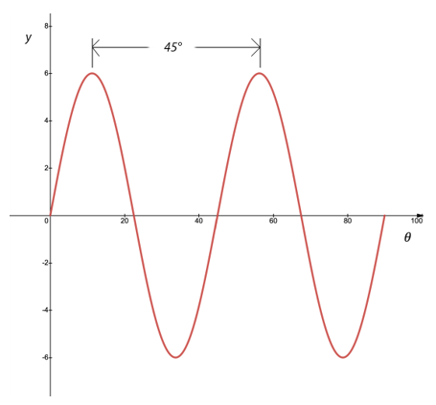

### 5.5 Try these

1. Write the equation of each graph.
2. 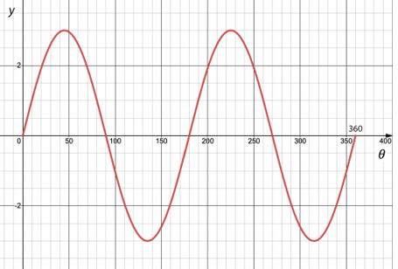
3. 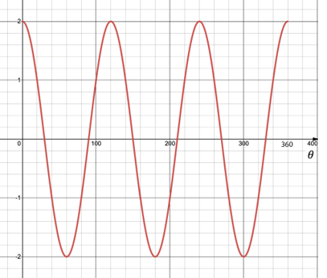
4. 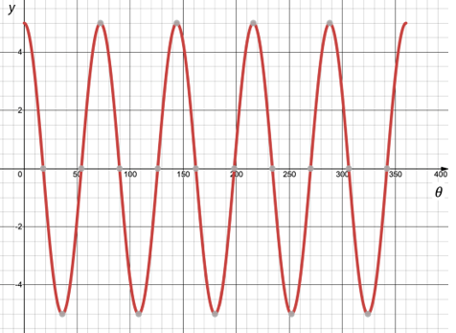
5. 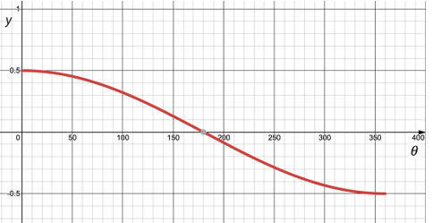
6. How many complete cycles are there in the graph of from 0° to 360°? What is the period and amplitude of this function?
7. How many complete cycles are there in the graph of from 0° to 360°? What is the period and amplitude of this function?
8. Write the equation of a sine curve that has amplitude 15 and period 50°. You need to specify both in . Keep in mind that the period of this function is .
9. Write the equation of a cosine curve that has amplitude 100 and period 12°. You need to specify both in . Keep in mind that the period of this function is .
10. Write the equation of a cosine function that has amplitude 3 and makes two complete cycles from 0° to 180°.
11. Write the equation of a sine function that has amplitude 4 and makes three complete cycles from 0° to 90°.

# ANSWERS TO TRY THESE

##### 

#### 1.1 Constants, Variables, and Expressions

1.

a) The variable quantity is the download cost.

b) The constant is the fixed service cost.

c) Annual cost = 50 + 2, where represents the number of downloaded photographs.

d) Annual cost = 50 + 220 = 50 + 40 = 90  
 The annual cost of downloading 20 photos is $90.

3.

a) There are 2 variable quantities in this problem.

b) There are no constants in this problem.

#### 2.1 Vectors

1. and

2. Two vectors are equal because they have the same direction and magnitude.

#### 2.2 Addition, Subtraction, and Scalar Multiplication of Vectors

1.

2.

#### 2.3 Magnitude, Direction, and Components of a Vector

1.

2.

3. and

4.

#### 2.4 The Dot Product of Two Vectors, the Length of a Vector, and the Angle Between Two Vectors

1.

2.

3.

4.

5.

6.

#### 2.5 Parallel and Perpendicular Vectors, The Unit Vector

1. Parallel

2. Perpendicular

3. Neither parallel nor perpendicular

4.

#### 2.6 The Vector Projection of One Vector onto Another

1.

2.

#### 3.1 Three Dimensional Vectors

1. units

2. units

3.

4.

#### 3.2 Magnitude and Direction Cosines of a Vector

1.

2.

3. {0.802, -0.267, 0.535}

4.

#### 3.3 Arithmetic on Vectors in 3-Dimensional Space

1.

2.

3.

4.

#### 3.4 The Unit Vector in 3-Dimensions and Vectors in Standard Position

1.

2.

3.

4.

#### 3.5 The Dot Product, Length of a Vector, and the Angle between Two Vectors in Three Dimensions

1.

2.

3.

4.

5.

6.

#### 3.6 The Cross Product: Algebra

1.

2.

3.

#### 3.7 The Cross Product: Geometry

1.

2.  **=**

3. = 12.2 units

4.

|  |
| --- |
|  |
|  |

5. Perpendicular since

6. Parallelogram is square units. Triangle is (½ of = square units.

#### 4.1 Matrices

1.

a)

b)

c)

2. True

3.

a) 5

b) 2

c) 1

d) 4

4.

5.

6.

7. <4,3,2>

8. or

#### 4.2 Addition, Subtraction, Scalar Multiplication, and Products of Row and Column Matrices

1.

2.

3. Not possible

4.

5.

6.

7. Not defined

8.

9.

10.

#### 4.3 Matrix Multiplication

1.

2.

3. Is not commutative

4.

5.

6.

7.

8.

9.

10.

11. Not defined

#### 4.4 Rotation Matrices in 2-Dimensions

1.

2.

3.

4.

5.

6.

7.

8.

9.

#### 4.5 Finding the Angle of Rotation Between Two Rotated Vectors in 2-Dimensions

1.

2.

3.

4.

5. = -

#### 4.6 Rotation Matrices in 3-Dimensions

1.

2.

3.

#### 5.1 The Basic Trigonometric Functions

1.

a) cos, tan

b) cos, tan

c) cos, tan

d) cos, tan

e) cos, tan

2.

a) , cos, tan

b) , cos

c) , cos, tan

d) , cos

e) , cos

#### 5.2 Circular Trigonometry

1. (0.7071, 0.7071)

2. (0.9962, 0.0872)

3. (6.4705, 4.8396)

4. (-7.0711, 7.0711)

5. 34.31 ft

6. 6 units

#### 5.3 Graphs of the Sine Function

1.

a) -0.7071

b) -1

c) -0.7071

d) 0

2.

a) 0.5

b) 0.7071

c) 0.8660

d) 1

3.

a) True, since 0.9986 > 0.9781

b) False, since 0.4226 < 0.5736

c) True, since 0.5 = 0.5

d) True, since

4.

a) True, since

b) False, since

c) True, since

d) True, since

#### 5.4 Graphs of the Cosine Function

1.

a) -0.7071

b) 0

c) 0.7071

d) 1

2.

a) 0.8660

b) 0.7071

c) 0.5

d) 0

3.

a) False, since 0.0523 < 0.2079

b) False, since 0.7071 < 0.9063 (Be careful here: 0.7071 > –0.9063, but the negative sign tells us the object is the left of the observer. Think absolute value. At 45°, the object is 0.7071 to the right of the observer. At 145°, the object is 0.9063 units to the left of the observer, and, therefore, farther from the observer.)

c) False, since is |0.8660| =|-0.8660|

d) True, since 0 = 0

#### 5.5 Amplitude and Period of the Sine and Cosine Functions

1.

a)

b)

c)

d)

2. 3 complete cycles. Period is Amplitude is 4.

3. of a complete cycle. Period is . Amplitude is 5.

4. , where

5. , where   
6.

We need to specify both in . Since the amplitude is 3 Since the curve makes two complete cycles from 0° to 180°, it must make 4 complete cycles from 0° to 360°. So,

7.

We need to specify both in . Since the amplitude is 4 Since the curve makes three complete cycles from 0° to 90°, it must make 12 complete cycles from 0° to 360°. So, .

# Teacher Notes

### 1.1 Constants, Variables, and Expressions

Consider showing this on the board. You can use it to discuss the meanings of the terms constants, variables, and expressions.

To produce a textbook, suppose the publisher spent $140,000 for typesetting and $5.50 per book for printing and binding.

* + 1. Which of the two quantities is the variable quantity?
    2. Which of the two quantities is the constant?
    3. Write the expression that produces the cost of producing number of books.
    4. What is the cost of producing 1000 books?
    5. What is the cost of producing the 1001st book?

ANSWERS:

1. The variable is the number of textbooks to be printed and bound.
2. The constant is $140,000 for typesetting.
3. The expression that produces the cost of producing number of books is

$5.50 + 140,000.

1. The cost of producing 1000 books is $5.50*(1000) + 140,000 = $145,500.
2. The cost of producing the 1001st books is

(The cost of producing 1001 books) – (The cost of producing 1000 books)

= ($5.50*(1001) + 140,000) – $145,500

= $145,505.50 – $145,500

= $5.5

### 2.1 Vectors

Consider showing these examples on the board.

1. Express the vectors , , , and in component form.

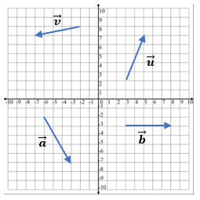

ANSWERS:

,

,

,

=

1. Illustrate the zero vector, . This vector has zero magnitude and no direction.

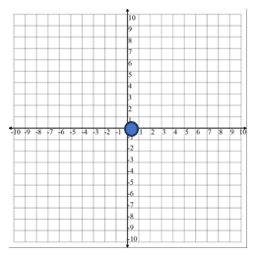

1. Illustrate why the two vectors and are equal.

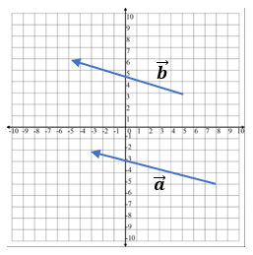

ANSWERS:

They are equal because they have the same magnitude and direction.

### 2.2 Addition, Subtraction, and Scalar Multiplication of Vectors

Consider showing these examples on the board.

1. Using the vectors and show addition using both the arrows originating at the origin and then by placing the tail of onto the head of .

ANS:

1. Subtract the vector from the vector .

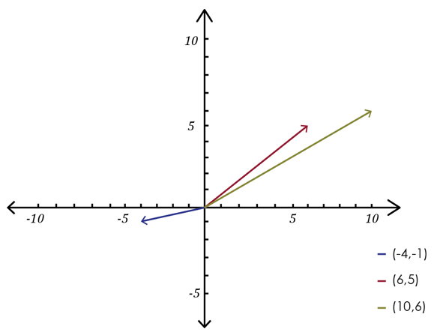

ANS:

1. Multiply the vector by the scalar 3.

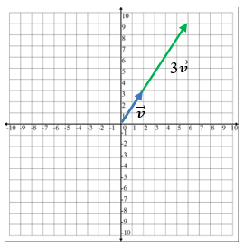

ANS:

Draw in one color and in another color. Point out how the length of vector tripled. That is, should look 3 times as long as . It can be a bit hard to show because the vectors will appear to be on top of the other.

1. Multiply the vector by the scalar -2.

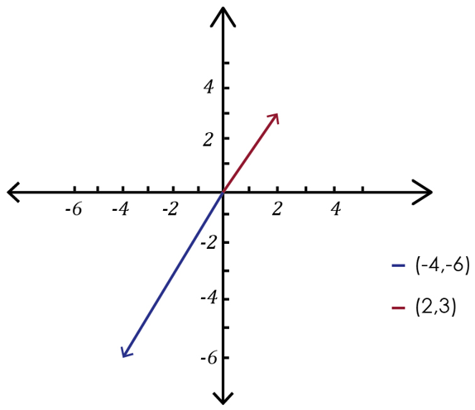

ANS:

Draw in one color and in another color. Point out how the length of vector doubled and points in the opposite direction of . That is, -2 should look twice as long as but pointing in the opposite direction.

1. Suppose and and . Find

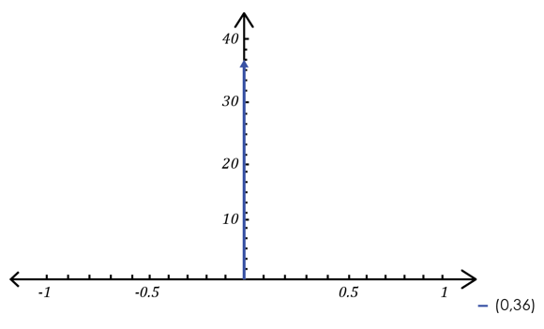

### 2.3 Magnitude, Direction, and Components of a Vector

1. Remind students of the Pythagorean Theorem.

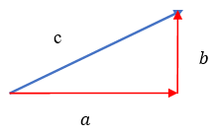

1. Consider deriving the magnitude of a vector using the Pythagorean Theorem. Note that the and the in represent the lengths of the horizontal and vertical components, respectively, of .

|  |  |
| --- | --- |
|  | A diagram showing the magnitude of a vector and its horizontal and vertical components. |

Use as an example of the vector . The magnitude of is

1. Demonstrate how to find the magnitude of .
2. Find the components of the vector if the magnitude of is 7 and it makes a 30° angle with the horizontal.

So, and

1. Approximate the components of the vector if the magnitude of is 16 and it makes a 128° angle with the horizontal.

So, and

1. Approximate the direction of the vector .

Using a calculator, we get

### 2.4 The Dot Product of Two Vectors, the Length of a Vector, and the Angle Between Two Vectors

1. Perhaps begin by discussing the zero vector . This vector is represented by a single point. It has a length of measure 0.

1. Define the dot product of two vectors. Note that it is just a definition, and not derived. Then follow with an example.

Find the dot product of the vectors and .

1. Although it is developed at the beginning of the chapter, consider proving that

. It is instructive for students to see proofs as it helps to develop their logic.

Proof: We want to show for a vector , that .

For a vector

By Vector Property 4, . This gives .

Taking the square root of each side produces

1. Find the length of the vector .

Using with and ,

Make a conclusion. The length of the vector is 5 units.

1. Discuss the angle between two vectors and show an example of how to use the inverse cosine on the calculator.

Find the angle between the vectors and .

Example

Use with , and .

On the TI-84, input 2nd(–36/(2nd

### 2.5 Parallel and Perpendicular Vectors, The Unit Vector

1. Show that and are parallel to each other.

Method 1

Make sure your calculator is in degree mode, not radian mode.

Method 2

Show that .Notice that .

1. Show that the vectors , and are perpendicular to each other.

Method 1

,

The dot product of these two vectors is 0.

Method 2

1. Find the unit vector corresponding to the vector .

### 2.6 The Vector Projection of One Vector onto Another

When presenting the projection formula, consider pointing out that the numerator is a dot product and a scalar (a real number). The denominator is a length, so it, too, is a scalar. A scalar divided by a scalar is also a scalar, so the formula shows a vector is multiplied by a scalar. That is, it shows a vector scaled longer or shorter. That scaled vector is the projection.

Consider working through these problems as examples.

1. Find the projection of the vector onto the vector .

ANS:

1. Find , where

ANS:

1. Find , where

ANS: These two vectors are orthogonal (perpendicular to each other).

### 3.1 Three Dimensional Vectors

Consider deriving the formula for the distance between two points. Let the two points be and Draw the two points and use the Pythagorean Theorem.

|  |  |
| --- | --- |
| By the Pythagorean Theorem,  Take square roots to get | Diagram of two points in a 2-dimensional coordinate system and use of Pythagorean Theorem to derive formula for the distance between those two points. |

The equation of a circle comes from the distance formula by using one of the points, say as the center and the other point, say as a general point on the circle. A circle is defined as a closed plane curve consisting of all points at a given distance from a point within the curve. Use the distance formula replacing with and with and with

Consider working through these problems as examples.

1. Find the distance between the two points and . Round to one decimal place.

ANS: units

1. Find the distance between the two points and . Round to one decimal place.

ANS: units

1. Write the equation of a circle that has as its center the point and radius 2.

ANS:

1. Write the equation of a sphere that has as its center the point and radius 3.

ANS:

### 3.2 Magnitude and Direction Cosines of a Vector

Consider presenting the formulas then working through these example problems.

1. Find the magnitude of the vector .

ANS:

1. Find the magnitude of the vector .

ANS:

1. Find the direction cosines of the vector . Round to three decimal places.

ANS: {0.784, 0.196, -0.588}

1. Approximate the vector that has magnitude 30 and direction cosines

ANS:

### 3.3 Arithmetic on Vectors in 3-Dimensional Space

Consider working through these examples.

1. Add the vectors

ANS:

1. Subtract the vector from the vector .

ANS:

1. Given the three vectors, , , and ,  
   a. Find .  
   b. Find the length of the vector .

ANS: a. =   
 b.

1. Suppose and , , and , find

ANS:

### 3.4 The Unit Vector in 3-Dimensions and Vectors in Standard Position

Consider working through these examples.

1. Write the unit vector that corresponds to

ANS:

1. Write the unit vector that corresponds to

ANS:

1. Normalize the vector

ANS:

### 3.5 The Dot Product, Length of a Vector, and the Angle between Two Vectors in Three Dimensions

1. Define the dot product of two vectors. Note that it is just a definition, and not derived. Then follow with an example.

Find the dot product of the vectors and .

1. Consider using an example to demonstrate why .

Show that the length of the vector = .

Let’s start by drawing this vector.

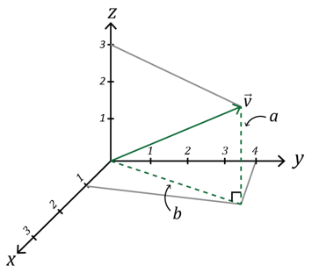

Notice that for the vector , there is a right triangle with base and height .

We can use the Pythagorean Theorem to find the length of .

Since the height of the triangle from the -plane to the tip of is 3 units, so, , we have

Now is itself the hypotenuse to its own triangle in the -plane. So,

Now, we have the length of .

In general, you can see that the length of is the square root of the sum of the squares of ’s components.

Consider as examples:

1. Find the dot product of the vectors and .

ANS:

1. Find the length of the vector .

ANS:

1. Find the length of the vector .

ANS:

4.Find the angle between the vectors and .

ANS:

5.Find the angle between the vectors and .

ANS:

6.Find a vector that is perpendicular to .

Two vectors are perpendicular to each other if the angle between them is 90° = . The cosine of the angle between two vectors is given by . We know that .

The gives us

A fraction is 0 only when the numerator is 0, so we are looking for a vector such that

. (Recall this from a previous section.)

Let the unknown vector . Then

Choose any numbers at all for and . Suppose , then

So, a vector that is perpendicular to is the vector

### 3.6 The Cross Product: Algebra

Consider demonstrating these examples.

1. Find the cross product of the vectors and .

ANS:

1. Find the cross product of the vectors and .

ANS:

### 3.7 The Cross Product: Geometry

Consider as examples:

1. Find the cross product of the vectors and .

ANS:

1. Find the cross product of the vectors and .

ANS:

1. Find the length of the vector .

ANS:

1. Find the angle between the vectors and .

ANS:

1. Find the angle between the vectors and .

ANS:

### 4.2 Addition, Subtraction, Scalar Multiplication, and Products of Row and Column Matrices

1. Consider using the matrices
2. Illustrate matrix addition,
3. Illustrate matrix subtraction,
4. Illustrate an addition that is not defined,
5. Illustrate the commutativity of matrix addition,

1. Consider using the matrices

,

1. Illustrate row and column matrix multiplication,
2. Illustrate the commutativity of row and column matrix
3. Illustrate multiplication,
4. Illustrate how dimension matters by showing that is not defined
5. Perhaps use the following example as a motivation for row and column matrix multiplication.

Suppose your business sells three sizes of artist’s paint brushes, small-sized brushes, medium-sized brushes, and large-sized brushes. Small brushes sell for $15 each, medium brushes for $20 each, and large brushes for $25 each. What would be your total revenue if you sold 50 small-sized artist’s brushes, 40 medium-sized brushes, and 30 large-sized brushes?

Using , your revenue from the sale of the

small brushes is

medium brushes is

large brushes is

The total revenue is just the sum of these three products,

We can compute the total revenue using two matrices and matrix multiplication.

Let the first matrix be the row matrix of the number of brushes sold,

and the second matrix be the column matrix of the number of boxes sold.

The total revenue is the matrix product .

### 4.3 Matrix Multiplication

1. Consider using the matrices to remind us of the process of row and column matrix multiplication, .
2. Consider using the matrices

, ,

1. To illustrate matrix multiplication, ,
2. And another multiplication,
3. That a matrix multiplication may not be defined, ,
4. That a matrix multiplication is not necessarily commutative,

### 4.4 Rotation Matrices in 2-Dimensions

Note that we plan to rotate some vector through some angle to the new position given by the vector , and to do so, we will use the rotation matrix, a matrix that rotates points in the -plane counterclockwise through an angle relative to the -axis.

Consider demonstrating these rotations:

1. Find the vector that results when the vector is rotated 90° counterclockwise.

Using the rotation formula with and we get

When rotated counterclockwise 90°, the vector becomes .

* If your class knows some trig, you can show the conversion of

to

Since

* If trig is a challenge, use WolframAlpha to perform the matrix multiplication.

Go to www.wolframalpha.com.

To find rotation of the vector, enter Evaluate [ [cos(90), –sin(90)], [sin(90), cos(90)] ] * [ 5, -5] into the entry field. WolframAlpha tells you what it thinks you entered, then tells you its answer.

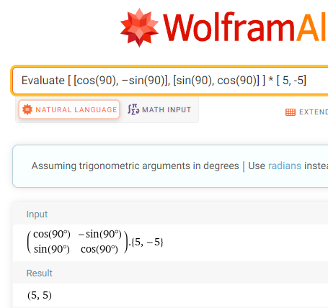

Be sure to write a conclusion so your students know to do so.

When rotated counterclockwise 90°, the vector becomes .

1. The rotation formula works for clockwise rotations. We just need to make the angle of rotation negative.

Find the vector that results when the vector is rotated –270°.

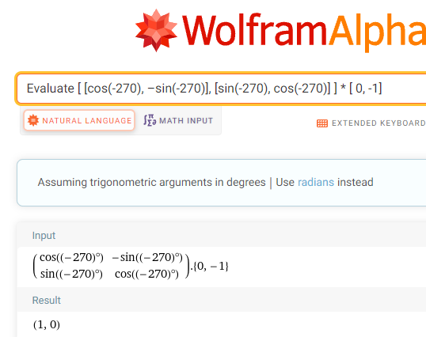

When rotated clockwise 90°, the vector becomes .

##### Deriving the Rotation Formula

If your class knows some trig, you may wish to derive the rotation formula.

We wish to derive a formula that rotates a vector counterclockwise through some angle to the new position given by the vector .

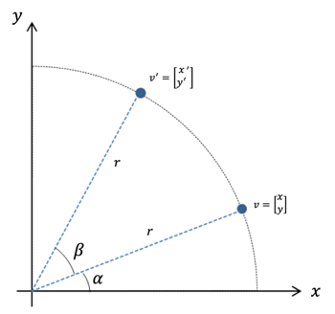

We wish to rotate the vector through an angle around the origin.

We know that in general,

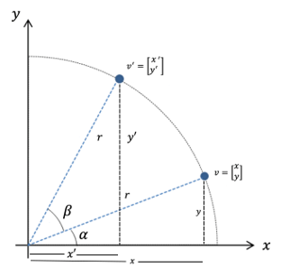

The figure shows that for angle ,

Also

By the trigonometry addition identity,

Then, since and

Replace with and with

Similarly, by the trigonometry addition identity,

Then, since and

Replace with and with

Rewrite this as

Now we have

Putting these two results into matrix form, .

Replacing with to match our notation, we get

And we have produced the rotation formula.

### 4.5 Finding the Angle of Rotation Between Two Rotated Vectors in 2-Dimensions

Note that to find the angle between the two vectors and , we use the rotation formula in reverse.

produces the system of equations

Consider demonstrating this example.

Find the angle through which the vector is rotated to become .

Use W|A to solve this system. Go to www.wolframalpha.com and enter  
Solve 1 = 1*cos(x) + 1*(–sin(x)), –1 = 1*sin(x) + 1*cos(x), 0 <= x <= 2*pi into the entry field.

Both entries and rows are separated by commas as W|A does not see spaces.

Wolframalpha tells you what it thinks you entered, then tells you its answer

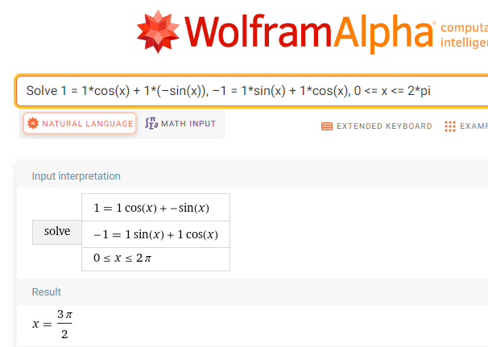

We conclude that the angle of rotation is

##### Using the Dot Product to find the Angle Between Two Vectors

You may wish to point out that the angle of rotation can also be found using the dot product formula from Chapter 2.4.

If is the smallest nonnegative angle between two non-zero vectors and, then

or

where and and .

Find the angle between the vectors and .

Using , we get

### 4.6 Rotation Matrices in 3-Dimensions

Consider noting that if we are familiar with the 2-D rotation matrices of Chapter 4.4, then the 3-D rotation matrix for rotating a vector around the –axis may not be a surprise.

* For 2-D, the rotation matrix is
* For 3-D, the rotation matrix around the –axis is

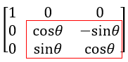

Look closely at the last two rows and two columns.

The 2-D rotation matrix shows up in the 3-D rotation matrix.

The fist column in the 3-D rotation matrix is

These are the numbers that when the multiplication is performed, keep the -component the same.

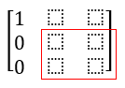

What happens in the and components is just a rotation in the plane. The -axis rotates counterclockwise toward the -axis, so in the lower right part of the 3x3 matrix, we will have the standard rotation matrix that we saw for the plane in Chapter 4.4.

Consider demonstrating these examples.

Find the vector that results when the given vector is rotated the given angle counterclockwise around the given axis.

1. through 90° around the –axis.

Using the rotation formula with and we get

When rotated counterclockwise 90° around the –axis, the vector becomes .

1. through 60° around the –axis.

Using the rotation formula with , and WolframAlpha we get

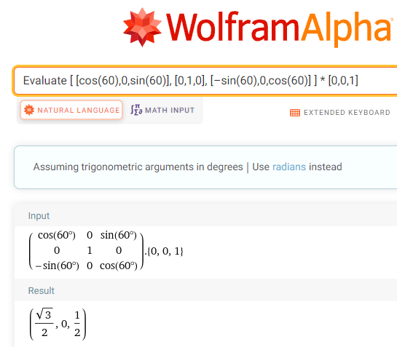

When rotated counterclockwise 60° around the –axis, the vector becomes .

### 5.1 The Basic Trigonometric Functions

This section is intended as a brief introduction to right angle trigonometry. It is not intended as even a brief course in trig. We present only the sine and cosine functions since they are the functions used in controlling vertical and horizontal motion of an object. They are two functions that best serve the needs of gaming programmers at an introductory level. We present the sine and cosine first using right triangles as they give a visual understanding of both functions.

The next section will present circular trigonometry. In computer games, vertical and horizontal motion of objects takes place over time, and the graphs of sine and cosine as time increases helps us to see how these two functions control vertical and horizontal motion.

The following section presents how the amplitude and period of the sine and cosine functions determine the height of an object and the speed at which an object changes its height.

Consider demonstrating these examples:

Find both and cosfor the 5-12-13 triangle.

Example (1)

|  |  |
| --- | --- |
|  | Right triangle with angle theta and sides 5, 12, and 13. |

Find

Example (2)

To compute these ratios, enter Evaluate sin(30), cos(30), sin(60), cos(90) into the entry field.

Separate the entries with commas. W|A does not see spaces.

WolframAlpha tells you what it thinks you entered, then tells you its answers.

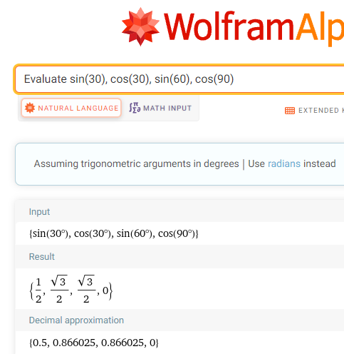

We conclude that and

W|A also provides us with decimal approximations to these ratios.

and.

### 5.2 Circular Trigonometry

We are using degrees rather than radians as most game players think in terms of degrees, not radians.

Consider demonstrating these examples:

1. An object lies on the circumference of a unit circle. Find its coordinates if the line segment from the origin to the object makes angle of 60° with the horizontal.

|  |  |
| --- | --- |
| Because the object is on the circumference of unit circle, we can use  and , with , .    The coordinates of the object are (0.5, 0.8660). | Object on unit circle with angle 60 degrees with the horizontal. |

1. An object lies on the circumference of a circle of radius 25 m. Find its coordinates if the line segment from the origin to the object makes angle of 120° with the horizontal.

ANS: (-12.5, 21.6506)

1. How high above the ground is an object that makes an angle of 50° with a 3-foot-tall observer’s eyes and is 100 feet away from that observer’s eyes? Round to two decimals places.

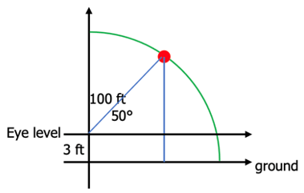

ANS: 79.60 ft

1. The coordinates of an object are (5, 12). Find its distance from the origin.

We can use the Pythagorean Theorem, , where is the hypotenuse, the radius of the circle in our case.

We conclude that the object is about 13 units from the origin.

### 5.3 Graphs of the Sine Function

The point of this section is to get the student to see how the sine function controls an object’s vertical distance from the horizontal.

Be careful to explain that the graph shows how the height of the object increases and decreases as the angle of view increases. Point out that the curve is NOT the path of the object. A common error students make is to think that the curve is the path of the object.

### 5.4 Graphs of the Cosine Function

The point of this section is to get the student to see how the cosine function controls an object’s horizontal distance from the observer. Point out that we should think of the cosine values in terms of absolute values since they represent distances to the left or right of the observer.

Be careful to explain that the graph shows how the horizontal distance of the object increases and decreases as the angle of view increases. Point out that the curve is NOT the path of the object. A common error students make is to think that the curve is the path of the object.

### 5.5 Amplitude and Period of the Sine and Cosine Functions

First, consider presenting the **amplitude** of the sine and cosine function.

Ask what would happen if we multiplied by 4.

If we were to multiply the sine function by , getting , each of the sine values would be multiplied by 4 making each value 4 times what it was. Each height would be quadrupled. The amplitude of is 4.

Now discuss what would happen if we multiplied by 1/4.

If we were to multiply the sine function by , getting , each of the sine values would be multiplied by , making each value of what it was. Each height of would be of what it was in . The amplitude of is .

To compare the graphs, use [WolframAlpha](http://www.wolframalpha.com/) or [Desmos](https://www.desmos.com/calculator) to construct the graphs of

, , and all on the same coordinate system.

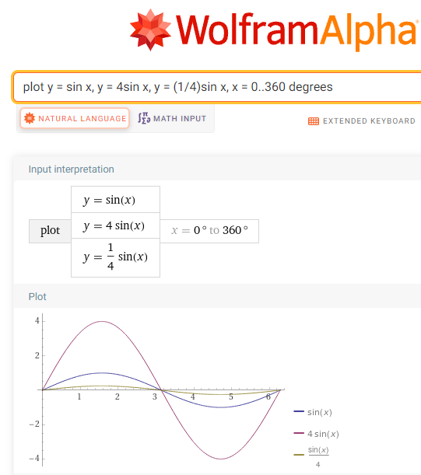

Now present the **period** of the sine and cosine function.

Suppose represents a positive number. Then the period of both and is As B gets bigger, gets smaller and the period increases.

Ask what would happen if we were to multiply the angle by

If we were to multiply the angle in the sine function by , getting , each of the angle’s values would be multiplied by 4 making each value 4 times what it was. Each angle would be quadrupled and there would be 4 cycles in the interval 0° to 360°. The period of is . The period of is smaller than that of .

Ask what would happen if we were to multiply the angle is multiplied by

If we were to multiply the angle in the sine function by , getting Each of the angle’s values would be multiplied by 1/4 making each value 1/4 what it was and there would be only 1/4 of a cycle in the interval 0° to 360°. The period of is = . The period of is greater than that of

For comparison, you could use WolframAlpha or Desmos to construct the graph of each of these functions on the same coordinate system.